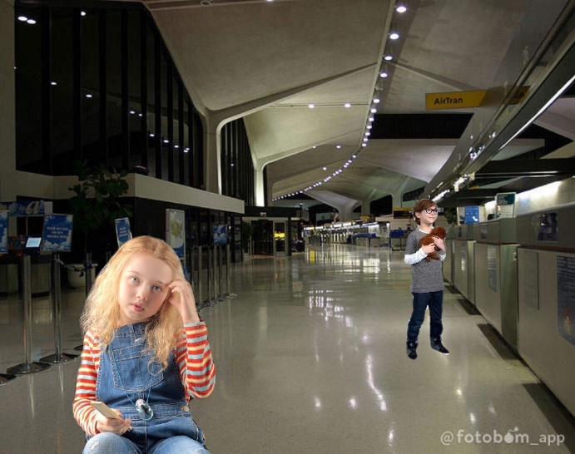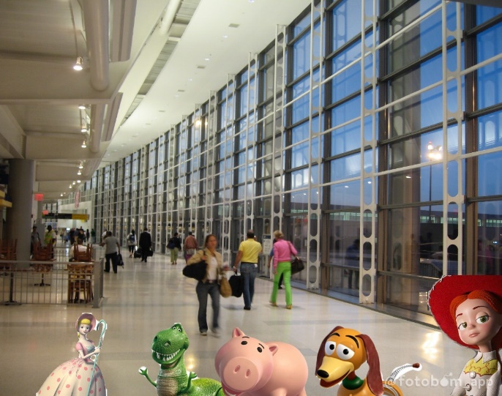
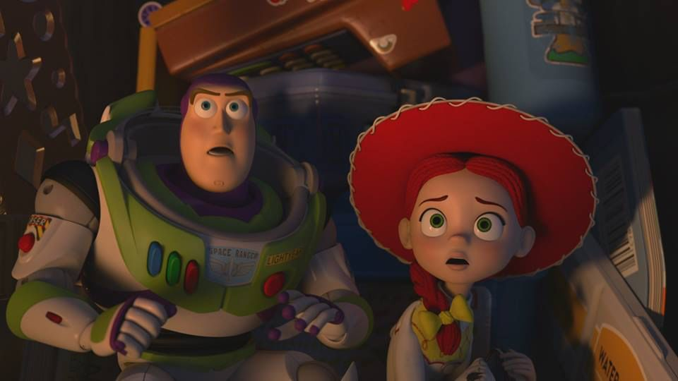
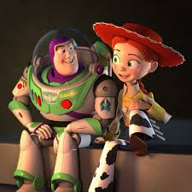
When Andy, Molly, and their parents arrived at the airport, the dad said immediately, “alright kids, go get out your luggage. I’ll go park the car and meet you kids up front.” Andy, Molly, and the mom got their luggage out of the trunk. They walked inside and up to the ticket agent’s front office. The mom said, “listen, flyboy, the contents of those cases are worth than you make in a year! You got that, sport?” “I understand, mam,” the ticket agent said with an agreement. Then, Molly came up front and said, “yeah, you be careful! I have toothbrush, toothpaste, mouthwash, jamies, boxes of cookies, and books!” In the back, the ticket agent checked Andy’s suitcase and put it on the conveyor belt with Molly’s and their parent’s luggage. Buzz unzipped the suitcase a little to peak outside to see if they’re moving. Buzz told Andy’s toys, “once when we go through, we just need to find Molly’s case.” Once when the suitcase went through flappers, Potato Head gasped when his butt spilled his stuff. Suddenly, the suitcase slid down the ramp. “Aaaahhh!” The toys screamed. Then, suitcase crashed at the end of the conveyor belt. Jessie peaked out of the suitcase and saw the gate opened and the suitcase went the wrong direction. She cried, “Buzz, we’re going on the wrong road!” “Where’s the case?” Hamm asked. Slinky saw Molly’s suitcase on the other conveyor belt. He shouted, “there’s the case!” “Quick, that way!” Bo said. Andy’s toys lifted the suitcase and rushed pass the other luggage jump off and onto another conveyor belt and then jumped onto the third conveyor belt reaching up to Molly’s suitcase. Both Andy’s and Molly’s luggage slid down the ramp just in time the baggage carrier put their luggage onto the luggage cart. The baggage carrier drove the luggage cart down to the airplane. The luggage carrier put each suitcase on the ramp. The luggage carrier shouted, “here’s the rest!” The other luggage carrier organized the luggage on the bottom of the airplane. Then, the plane was ready to take off.
When the plane arrived in the Orlando Airport, the luggage carrier took out each luggage on the bottom of the airplane. Then, the luggage carrier took out both Molly’s and Andy’s luggage and put them on the ramp. Once when the other luggage carrier put the last 2 luggage on the luggage cart. The other luggage carrier drove the luggage cart to the bottom conveyor belt. He put each luggage on the conveyor belt especially Molly’s and Andy’s luggage. Once when Andy’s and Molly’s luggage returned into the Orlando airport, Molly got her suitcase and Andy got his suitcase too. The mom and the dad also got their luggage. The dad asked, “does everyone got their suitcases back?” “I already have my suitcase,” Andy said. “I got mine,” Molly said too. “Good! Let’s take the Walt Disney World bus!” The mom said. While Andy, Molly, and their parents walked their luggage to the bus, Bo peaked out of Andy’s suitcase and saw that they made it to Orlando. She said, “well, looks like we made to Orlando already.” “Are we there already?” Rex asked. “What’s goin’ on?” Hamm asked. Andy handed his suitcase to the bus driver. The bus driver put Andy’s suitcase in the back of the trunk. “It’s safer in the cargo bay than the cockpit. What an idiot,” Woody groaned. The bus driver drove the bus out of the Orlando airport. The toys inside Andy’s suitcase pushed back at the end of the trunk! When the bus drove up the ramp, the luggage slid down at the back of the trunk. “Aaaahhh!” Woody screamed as the suitcase in the front slid back and crush onto the toys!
When the bus arrived at the Toy Story Hotel at the Walt Disney World resort, the bus driver took out Andy’s and Molly’s luggage out of the trunk and handed their luggage to Andy and Molly. The dad said, “well, here we are. At the Toy Story Hotel. Go grab your suitcases and let’s go check in.” While Andy, Molly, and their parents walked their luggage inside the Toy Story Hotel, Buzz peaked out of the suitcase and saw that they made it to the hotel. He said, “Jessie, we made it to the Toy Story Hotel.” “I hope there’s a play area where we can have some play time,” Jessie said. “Oh wait and see, Jessie,” Woody said, sternly. The hotel manager chuckled, “if you could just sign here in the guestbook, I’ll need to see a major credit card for the incidentals. Okay, let’s see here. I’m going to put you in room nine.”
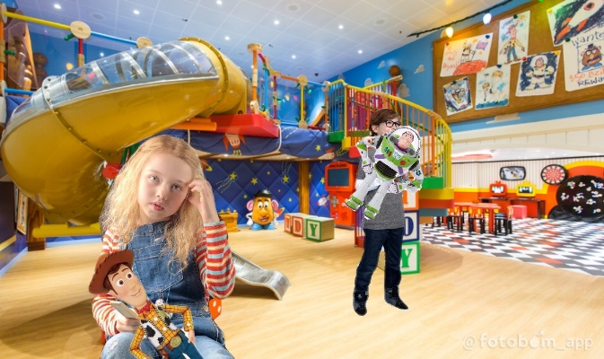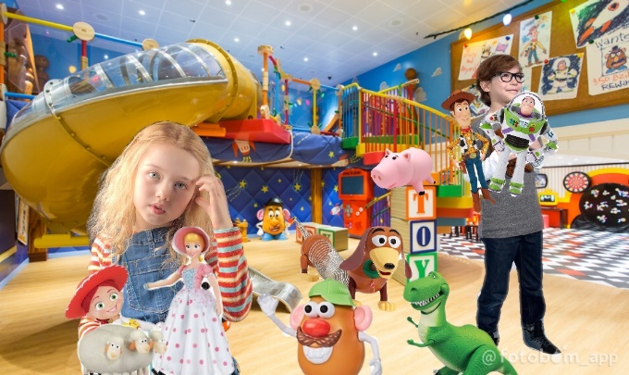
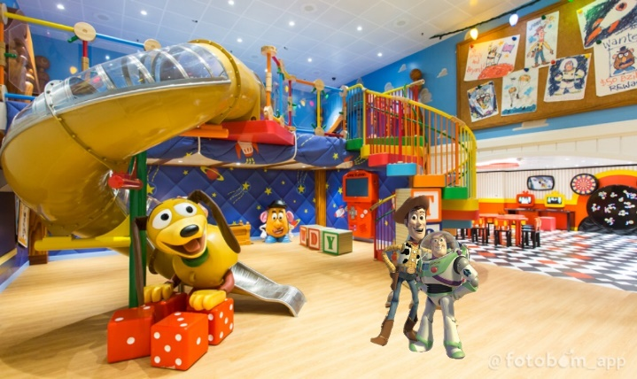
So, Andy, Molly, and their parents walked their luggage into room nine with a large playroom. They started to unpack their suitcase. Molly put Andy’s toys on the floor of the playroom. Andy put his LEGO Minifigures on the table in the playroom. Then, the mom came over and asked, “hey Molly! Andy! Since there’s plenty of time, would you like to go visit Magic Kingdom in Walt Disney World now?” “Sure, mom!” Andy said, happily. “That would be fun!” Molly said, excitedly. Andy started to say, “ooh, I almost forgot. I won’t bring one of my toys to Magic Kingdom, but what about Disney Hollywood Studios tomorrow?” The mom said, “well you can only bring 3 toys.” Just 3?” Andy said.
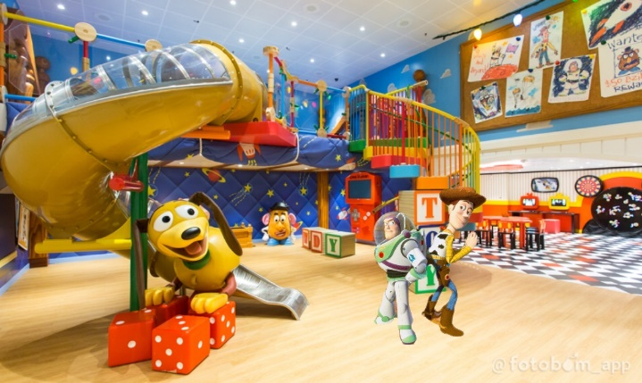
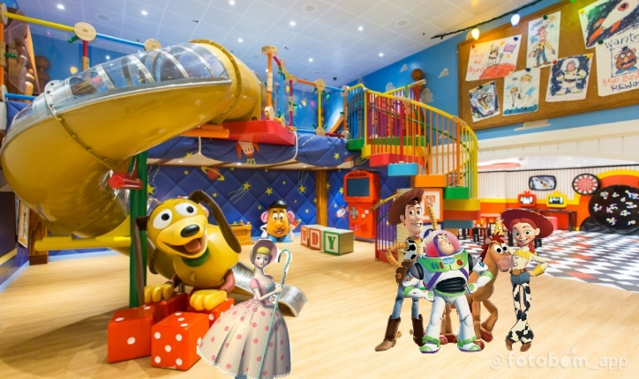
After Andy, Molly, and their parents left to got to Magic Kingdom, Rex got up and saw and saw Andy, Molly, and their parents were gone. He said, “well, looks like they left for Magic Kingdom.” “Finally,” Potato Head said. Right when Potato Head started to jump off the bed, Jessie asked, “Potato Head, where are you going?” “We’re at a hotel. I just wanna check out the amenities,” Potato Head explained. “You know, the free stuff: little soaps, shower caps, shampoo, and conditioner?” “Oh, I wouldn’t go out there if I were you. The first to leave usually gets it,” Hamm explained. “Oh, Potato Head, don’t leave the bed. A hotel is one of the easiest places for a toy to get lost!” Woody cried. “Aw, shut your worry hole! Nobody’s gonna getting lost. Besides, I promised Hamm I’d bring him back something nice,” Potato Head exclaimed. Jessie saw Rex, Hamm, Slinky, and Bo started to get out of the bed. Jessie asked, “wait. Where are you guys going?” “We were just gonna check out the free stuff,” Bo answered. “Aw, come on, guys! Let’s all just stay on the bed,” Woody sighed. “Buzz, I’ll grab those guys. You get Potato Head.” “Got it,” said Buzz. Right when Buzz got off the bed with Woody, Jessie tried to say, “no, wait. Don’t go!” Jessie decided to get off the bed too.
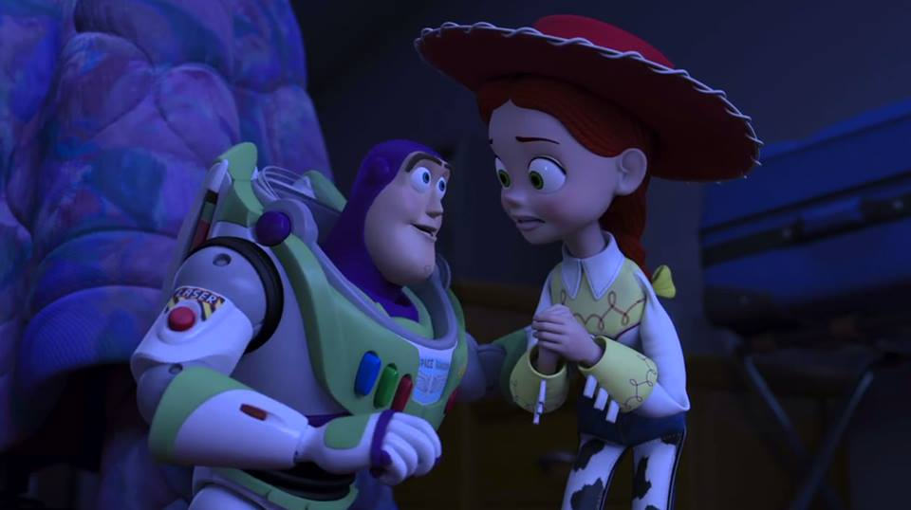
Then, Woody, Jessie, Bo, Buzz, Rex, Slinky, Hamm, and Potato Head came up to Emmet, Lucy, Rex, Benny, Batman, Lloyd, Unikitty, Marla and Charlie. “Woody!” Emmet called out. “Hey Emmet, who are your new friends?” “Woody, I would like you to meet my new friend, Rex,” Emmet introduces Rex to Woody. “That’s my name, Rex Dangervest. Galaxy Defending, Archaeologist, Cowboy, Raptor Trainer, who likes building furniture, Bustin Heads, and heavy chiseled features previously hidden under baby fat,” Rex introduced to himself. “Oh, I’m so glad you’re not a dinosaur!” Rex the T-Rex smiled as he shook his finger to Rex’s hand. “Well, thank you, Rex…” Rex tried to reply with a compliment, but then he realized that Rex the T-Rex is the same name as Rex Dangervest. “Hey, you have the same name as I am?” “I have?” Rex the T-Rex asked, thoughtfully. “Are those the other LEGO Minifigures?” Buzz asked, thoughtfully. “No, those are Playmobil,” Lucy answered. “Yeah, my name is Marla and that’s my brother, Charlie,” Marla introduced to themselves. “I’m so glad that you’re not a LEGO Minifigure!” Jessie said, happily as she leaned down and shook Marla’s hand. “Wh-why, thank you! Now, thank you all for your kind welcome, but he has school tomorrow and he should’ve been in bed in like 2 hours ago,” Marla tried to exclaim. “What did I tell you, earlier? You are a Playmobil toy!” Emmet told Marla. “Well, Emmet, Lucy, Rex, Benny, Batman, Lloyd, and Unikitty, something really weird happened. Andy made a friend today!” Woody announced. “What a kid. He’s already making friends,” Unikitty smiled. “No, no. She literally made a new friend,” Woody exclaimed. Woody came over to the suitcase to get Forky out. He said, “hey, it’s okay. Come on out. That’s it. Come on, there you go. Come on, let’s get you out of there. You got this. Good. Good.” Woody introduced Forky to the toys. “Everyone, I want you to meet Forky.” “Look at that!” Emmet said. “Look how long his arms are!” Benny said. “Trash?” Forky asked, thoughtfully. “No, toys,” Woody chuckled. “! They’re all toys.” “T-tr-trash?” Forky joked. “No, no, no. That’s the trash. These are the LEGO toys!” Woody corrected Forky. “Hi!” The LEGO Minifigures said. “Aaaaahhh!” Forky screamed as he fell down and his googly eye popped out. “Trash!” Forky cried. “No, no, it’s okay,” Woody said, kindly as he tried to help Forky. “Trash!” Forky cried as he headed toward the trash can. “Uh, why does he want to go to the trash?” Batman asked. “He’s just confused that he looks like he was made from trash,” Woody explained as he tried to drag Forky away from the trash can. “Look, I know this is a little strange, but you gotta trust me on this. Forky is the most important toy to Andy right now.” “Important? He’s a spork,” Marla exclaimed. Yes. Yeah, I know, but this spork… I meant this toy is crucial to Andy getting adjusted to his birthday party,” Woody exclaimed too. “Woody, aren’t you being a little dramatic about all this?” Lloyd asked. “I know this new to everybody because we’re all very impressed with Andy’s new toy, but you should see how much this little guy means to Andy,” Woody explained. “When she started playing with him, he had the biggest smile on his face. I wish you could have seen it.” “Uh, Woody?” Lucy tried to ask a question, but Woody interrupted by continuing, “Just a second, Lucy. So, we all have to make sure nothing happens to him.” “Something happened to him,” Lucy groaned as she pointed at Forky climbed up to the trash can. Woody turned around and say Forky fell into the trash can. “Oh, Chutes and Ladders!” Woody gasped as he rushed over to the trash can. “No, no, no! What did I tell you earlier? You’re a toy now, Forky! Come on! Stop! Stop it! Hey! No, no, no! Come on!” Woody tried to get Forky out of the trash can, but then he tipped the trash can to let them both out. “Well, I guess I’ll just babysit him till he learns that he’s a toy.”
Suddenly, Jessie heard that Andy, Molly and their parents were coming back to room 7. She called out, “Andy’s coming back! Everybody, back to your places! Hurry! Woody, take Forky back to the case! Hurry!” Woody took Forky back to the suitcase, quickly. All of Andy’s toys hurried back to their places and froze. When, Andy, Molly, and their parents came back to their room, Andy was looking all over for Forky. “Forky? Where are you, Forky?” Andy asked. Woody tossed Forky onto the bed. Molly pointed out by saying, “Forky is over here!” Andy turned around and smiled, “there you are! I thought I’d lost you silly.” Forky kept hopping into the trashcan and then Woody kept tossing Forky onto the bed.
Later that night, Andy, Molly, and their parents were asleep on their beds, but not Forky. Forky kept hopping into the trashcan. Woody sighed when Forky kept hopping in the trashcan. So, he climbed Forky onto the bed next to Andy. Forky cried, “no, no, no. Big boy scary!” Woody whispered, “like I said before, Andy’s not scary. He loves you and you need to…” Andy hugged onto Woody asleep.
The next morning, when Woody woke up, he saw Forky was gone. “Forky?” Woody called out. Then, he saw Forky asleep in the trashcan. Woody saw the dad was about to wake up. He fell off the bed and tipped the trashcan to let Forky out. The dad called out, “Let’s go Andy and Molly! Rise and Shine! Who’s ready to go to Disney’s Hollywood Studios?” “Me!” Molly shouted. “I do, but how many toys should I bring?” Andy asked. “Only 3 at a time,” the dad answered. “Great. I’ll bring Woody, Buzz, and Forky…” Andy called out. “Forky? Where are you?” “He’s gotta be here somewhere,” the dad said. Woody tossed Forky back on the bed. “Forky!” Andy said, happily. “Come on. Let’s eat some breakfast and pack Woody, Buzz, and Forky!” The dad said. “And then I’ll bring Emmet, Rex, Lucy, Charlie, and Marla to LEGOLAND!” Andy continued.
Later, Andy, Molly, and their parents took a bus to Disney’s Hollywood Studios. While, they’re riding on the bus, underneath, Woody was staring at Forky to make sure nothing bad happens to him. Buzz saw Woody staring at Forky too. Buzz came over to Woody and whispered, “hey, buddy.” “Hey, Buzz,” Woody replied. “You doing okay?” Buzz asked. “I don’t know, Buzz,” Woody replied. “I know you weren’t around when Andy was little, but I don’t remember it being this hard.” “Want me to take the next watch? I’ll keep an eye on Forky.” Buzz asked. Woody exclaimed, “no, no. I need to do this. That little voice inside me would never leave me alone if I gave up.” “Who do you think it is?” Buzz asked. “Who?” Asked Woody. “The voice inside of you. Who do you think it is?” Buzz asked. “Uh… me? You know my conscience? The part of you that tells you things? What you’re really thinking?” Woody asked, thoughtfully. “Fascinating. So, your inner voice advises you,” Buzz said as he felt Woody’s pull-string. “What? My voice box?” Woody asked, thoughtfully. Buzz pressed the red button on his chest. “I am Buzz Lightyear, Space Ranger,” Buzz’s voice box said, but Woody pushed Buzz to the back of the bus. Woody and Buzz looked up at Andy and Molly and saw that Forky was gone. “Where’s Forky?” Buzz asked. “Oh no! Forky!” Woody gasped. Then, Woody saw Forky climbing off the roof. He said, sternly, “I am not a toy! I’m a spork. I was made for soup, salad, maybe chili, and then the trash. I’m litter! Freedom!” Suddenly, Forky flew off the bus. Woody asked, “Buzz, how far to Disney’s Hollywood Studios?” Buzz looked at the traffic sign that says 1 1/2 miles. He said, “1.32 miles, give or take.” “We can make it there on time. Come on, Buzz.” Woody said as he was about to climb off the window. “Woody, hold on a minute. Woody!” Buzz tried to call out as he was about to climb off the window too.
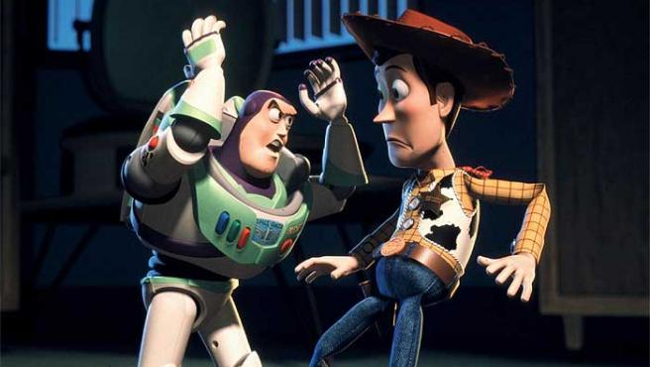
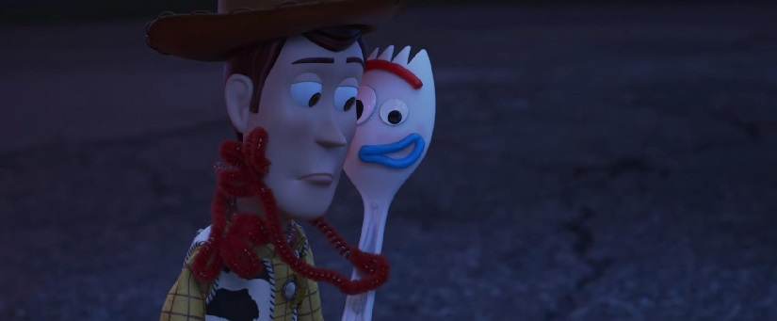
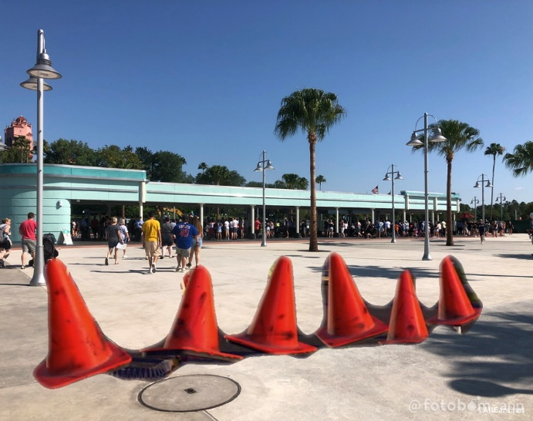
Woody stood on the side of the bus. Buzz leaned out the window and said, “Woody, wait!” Suddenly, the bus bounced on the curb. Woody and Buzz fell off the bus. Woody put his hat back on. Buzz and Woody saw that the bus left without them. “Andy!” Woody cried. “Doesn’t he realize that I’m not there? I’m lost! Oh, I’m a lost toy!” Woody began to cry. Buzz looked everywhere for Forky. He called out, “Forky! Forky, where are you, buddy?” Woody turned around and called out, “Forky! Forky, where are you? Forky!” Woody saw Forky stuck on the ground. After Buzz and Woody helped Forky get off the ground, Woody and Buzz walked Forky to Disney’s Hollywood Studios. While they’re walking, Forky asked, “carry me?” “No,” Woody said, sternly. Buzz said, “Actually, you are carrying Forky, right?” “Shut up! Just shut up, you idiot!” Woody said, angerly. “Woody, this is no time to panic,” Buzz said, angerly. “This is the perfect time to panic. I’m lost. Andy is gone,” Woody cried and panicked. “They’re on their way to Disney’s Hollywood Studios, and it’s all your fault!” “My fault? It’s all Forky’s fault for jumping off the bus and made us become lost too,” Buzz replied. “So, it’s my fault, right?” Forky said, thoughtfully. “Yes, it is all your fault,” Buzz said, sternly. “Why do I have to be a toy?” Forky asked. “Because you have Andy’s name written on the bottom of your sticks,” Woody answered. “Why do I have Andy’s name written on the bottom of the sticks?” Forky asked. Woody exclaimed, “look, he plays with you all the time, right?” “Ugh, yes,” Forky groaned. “And who does he sleep with every night?” Buzz asked. “The big white fluffy thing?” Forky asked, thoughtfully. “No, not the pillow. You,” Woody groaned. “Alright, Forky. You have to understand how lucky you are right now. You’re Andy’s toy. You are going to help create happy memories that will last for the rest of his life.” “Just like how when Andy was in Kindergarten, I thought I was a Space Ranger of Star Command, but he’s right that I’m just a toy,” Buzz explained too. “What? What are you talkin’ about?” Woody gasped. “Right now, poised at the edge of the galaxy, Emperor Zurg has been secretly building a weapon with the destructive capacity to annihilate an entire planet! I alone have information that reveals this weapon’s only weakness. And you, my friend, are responsible for delaying my rendezvous with Star Command and realizing that I’m just a stupid toy!” Buzz explained. Forky stared at Woody. He smiled, “Woody, I know what your problem is.” “You do?” Woody asked, thoughtfully. “You’re just like me. Trash!” Forky joked. “What is it with you and trash?” Woody asked. “It’s warm,” Forky answered. “Ew,” Woody groaned. “It’s cozy,” said Forky. “I guess,” Woody groaned. “And safe! Like somebody’s whispering in your ear, “Everything’s gonna be okay,” Forky whispered. “You… are… a… toy! You aren’t made out of trash! You made out of creative art! You are a child’s plaything!” Woody shouted. “You are a sad, strange little man, and you have my pity,” Buzz gasped. Then, Forky realized what Woody just explained. He asked to himself, “wait a sec. You mean he thinks I’m warm?” “Yep,” Buzz answered. “And cozy?” Forky asked, thoughtfully. “Uh, huh,” Woody smiled. “And sometimes kinda squishy?” Forky asked. “Well, that, too. Yes,” Buzz answered. Forky gasped, “I get it now. I’m Andy’s trash.” “Yes! Wait, what?” Buzz gasped. “I am Andy’s trash!” Forky smiled. “No, no, no, not exactly,” Woody exclaimed. “She must be feeling awful without me. Woody, Buzz, we got to get going, he needs me! Hey, Andy, I’m coming!” Forky said, excitedly, as he ran down to the entrance of Disney’s Hollywood Studios. “Forky, slow down! Forky!” Woody called out as he ran after Forky into Disney’s Hollywood Studios. “Andy, I’m coming!” Forky shouted. “Forky!” Buzz called out as he ran after Forky into Disney’s Hollywood Studios too.
When Forky, Buzz, and Woody arrived at the front entrance of Disney’s Hollywood Studios, they hid behind the trash can and saw Andy, Molly, and her parents walking inside Disney’s Hollywood Studios entrance with their fast pass. Buzz said, “Now, the entrance is heavily guarded. We need a way to get inside.” Forky put a small fry box over himself. “Great idea, Forky. I like your thinkin’,” Buzz smiled. Woody hid inside a big cup. Buzz hid inside a burger box. Forky hid inside a small fry box. They sneaked through the entrance. Once they were inside, Buzz bumped into Woody. “Ow! Watch where you’re going!” Woody said, angerly. “Sorry,” said Buzz. “Forky, wait for us!” Woody called out. Forky ran after Andy all the way up to Toy Story Land. Woody and Buzz followed Forky up to Toy Story Land.
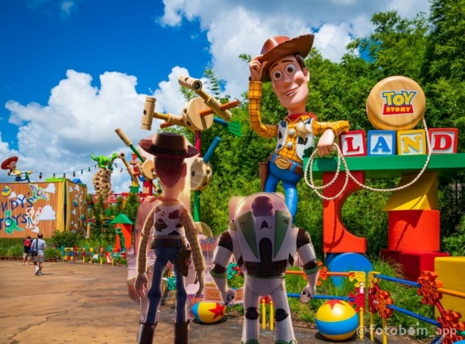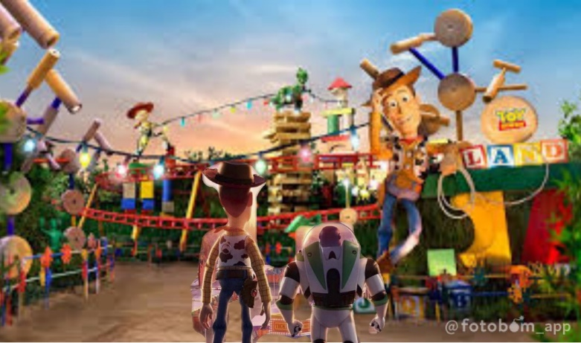
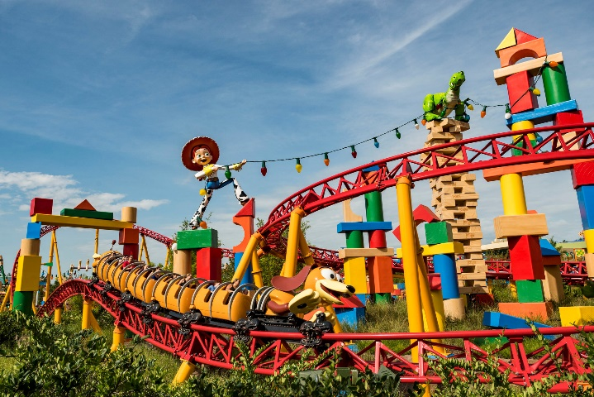
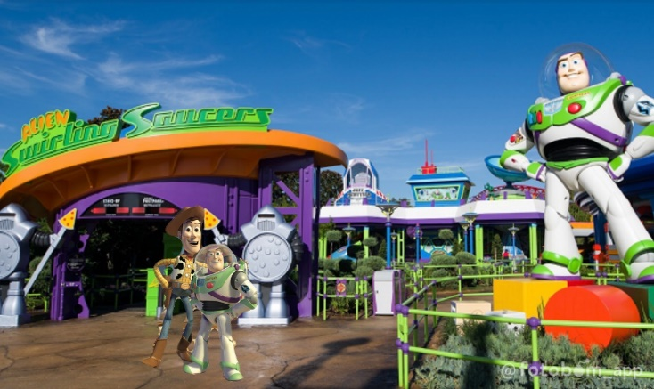
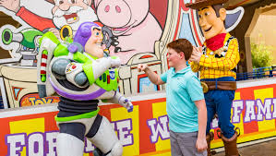
Woody and Buzz could see the whole Toy Story Land. “Holy cow,” Woody gasped. “What is this place?” Buzz asked. “We’re in… Toy Story Land!” Woody answered. “There’s an entire land here!” Buzz gasped. “Have you seen Forky?” Woody asked. Woody saw Forky heading onto Alien Swirling Saucers ride. “There he is!” Buzz pointed out. Woody and Buzz hopped onto their Alien Swirling Saucer and Forky hopped onto his Alien Swirling Saucer. The ride began to start and the Alien Swirling Saucers began to go around and around. Buzz and Woody tried to grab Forky’s arm, but they can’t reach over them. Forky had so much fun riding on the Alien Swirling Saucer. When the ride stopped, Forky saw the Slinky Andy, Molly, and their parents riding on the Slinky Dog Dash. He shouted, “Andy, here I come!” Woody and Buzz saw that Forky was heading toward the Slinky Dog Dash. Buzz asked, “now where did he go?” “He’s heading for the roller coaster!” Woody answered. “But we’re too short to ride on the roller coaster,” Buzz exclaimed. Right when Forky walked up to the entrance, Woody used his pull-string to pull Forky back to Woody. He said, “sorry, Forky. You’re too short to ride on the Slinky Dog Dash.” “Too short?” Forky gasped, thoughtfully. Woody and Buzz hid Forky behind the Measuring board. Andy, Molly, and their parents walked out of the Slinky Dog Dash. Woody spotted Andy. “Andy!” Woody smiled. “Now, we need to find where Andy is now,” Buzz said, thoughtfully. “Wait a minute. No, Buzz! This way. Andy is heading onto Toy Story Mania ride. I just saw it,” Woody exclaimed as he pulled Woody and Forky to the Toy Story Mania ride. “You mean it was hyperdrive?” Buzz asked, thoughtfully. “Hyperactive hyperdrive and Astro… uh, turf!” Woody exclaimed. “Hey, that’s what you and I play together all the time!” Buzz exclaimed. “Yeah, but…” Woody tried to respond, but Buzz interrupted by saying, “let’s follow Andy to ride on Toy Story Mania.” While Buzz carried Forky inside the Toy Story Mania ride, Woody tried to call out, “no, no, no, wait, Buzz! Buzz!” Woody followed Buzz and Forky inside the Toy Story Mania ride.
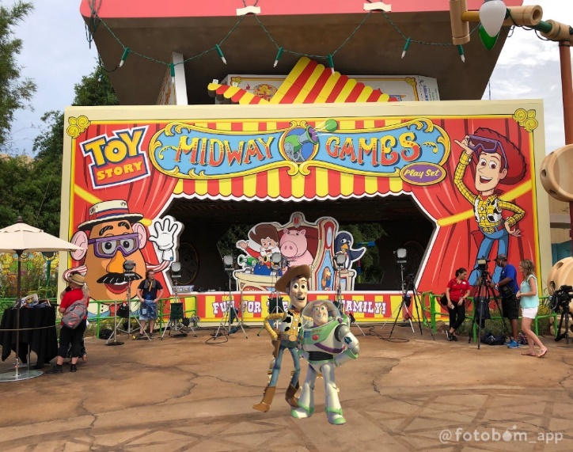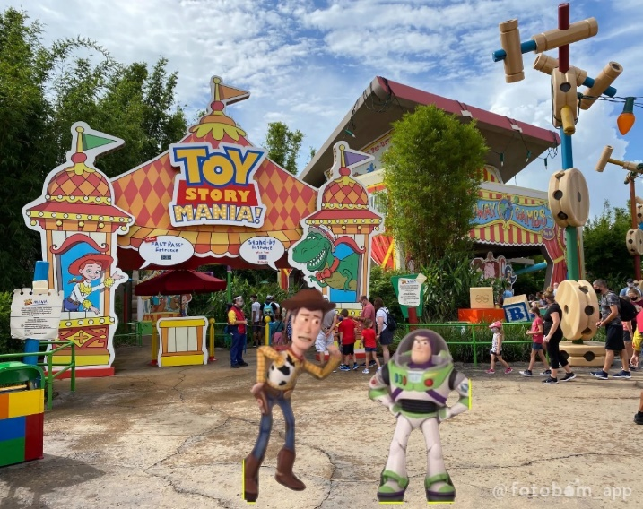
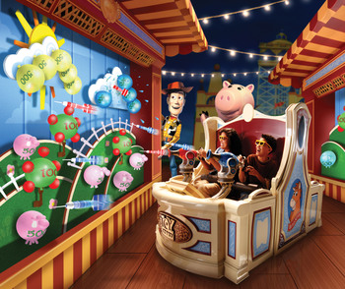
When Woody, Buzz, and Forky went inside, Woody asked, “have you seen Andy anywhere?” Buzz spotted Andy and said as he pointed out, “There he is!” Woody and Buzz took 3 pairs of 3D glasses. “Buzz, what are those?” Forky asked, as he saw through the 3D glasses. “Those glasses let you see in the 3rd dimention,” Buzz answered. “What? Let me see that…” Woody gasped, as he looked through the 3D glasses. “Whoah! This is like 3D!” “Uh, Woody, Andy’s leaving!” Buzz gasped. Woody, Buzz, and Forky hopped onto the swirling cart and they rode through Toy Story Mania. Woody, Buzz, and Forky had so much fun shooting targets for points at the Toy Story Mania ride. When they came out of the Toy Story Mania ride, Woody said, happily, “That was fun! So, where’s Andy now?” Forky ran over to Andy and shouted, “Hey, Andy! I’m coming!” “Forky, wait for us!” Woody shouted.
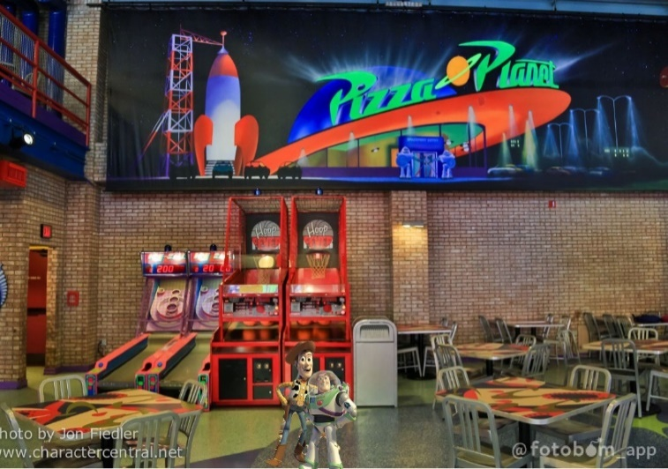
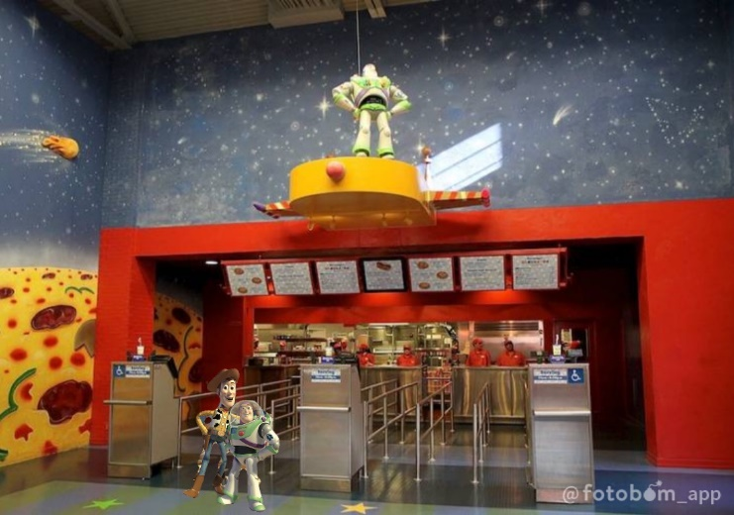
While Forky and Woody ran to Andy, Buzz spotted the rocket ship inside Pizza Planet. “The spaceship! Now I can go home!” he said. Buzz didn’t pay attention to Woody and Forky, so he decided to went inside Pizza Planet. Suddenly, Woody turned around and saw Buzz climbed inside the rocket. He gasped, “Buzz!” Woody turned back around and saw Forky hopped and climbed inside Andy’s backpack without Woody and Buzz. Woody grunted, “no! This cannot be happening to me.” Woody followed Buzz inside Pizza Planet. Inside the rocket, Buzz climbed aboard and saw the rocket was really a machine full of prizes. The prizes were little green alien toys. The aliens said, “A stranger. From the outside. Ooh!” “Greetings. I am Buzz Lightyear. I come in peace,” Buzz told the aliens. The aliens raised their hands. When Woody came inside Pizza Planet, Woody knew he had to rescue Buzz. So, he climbed into the rocket, too. Inside, Woody heard Buzz telling the aliens, “I’m not really a Space Ranger. I’m a toy. I’m just here to stop by for a slice of pepperoni before I head back to Andy’s. So, who’s in charge here?” The aliens pointed up and said, “the claw! The claw is out master. The claw chooses who will go and who will stay.” “This is ludicrous,” Woody gasped. Suddenly, Woody saw a toy collector named Al. He recognized him from the commercial. “Oh, no! It’s Al! Get down!” Woody gasped as he climbed over and pushed Buzz down underneath the aliens. Underneath, Buzz asked, angerly, “what’s gotten into you? I was…” Woody interrupted, angerly, “you are the one that decided to climb into this!” Suddenly, Woody and Buzz saw Al came up to the rocket machine to put in the tokens. Buzz froze on top. Al saw Buzz inside the rocket machine. He gasped, “a Buzz Lightyear? No way!” Woody knew that Al the claw is going to grab Buzz and lift him up. So he looked for another exit. He spotted a little door. Right when he opened the door, the claw lowered and grabbed Buzz. “Yes!” Al smiled. Right when the claw lifted Buzz up, Woody saw Buzz was lifting up. “Buzz! No!” Woody gasped, as he tried to grabbed Buzz’s legs and pulled him down. “What the?” Al gasped. Woody was very strong to try to save Buzz, but instead, the aliens pulled Woody back up. The aliens said, “he has been chosen! He must go! Do not fight the claw.” “Hey! What are you doing? Stop it! Stop it, you zealots!” Woody said, angerly. Woody got picked up, too. “Alright! Double prizes!” Al said, happily. When, Al picked Woody and Buzz out of the prize box, he looked closely at Woody. He said to himself, “he has a hat, boots, sheriff badge, original hand-painted face, and natural-dryed blanket-stitched vest! I found it!” Al looked closely at Buzz. He said to himself again, “read lazer lightbulb arm, star command mission log arm, wings button, and original hand-painted face! I found it! I can’t wait to take those to my office!” Al took Woody and Buzz out of Pizza Planet.
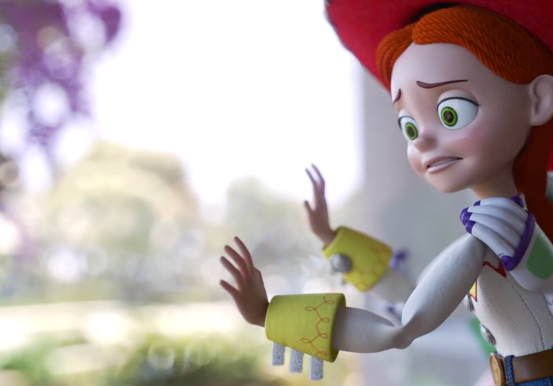
Meanwhile, Emmet was making a plan with Lucy, Rex, Benny, Batman, Lloyd, and Unikitty. Emmet announced, “okay, Woody, Buzz, and Forky has gone to Disney’s Hollywood Studios. Now, Andy will pick you, Rex, Marla, Charlie, and me to go to LEGOLAND Florida. So whatever we do, don’t get left behind.” Suddenly, Lucy heard Andy, Molly, and their parents came back to the Toy Story Hotel. She interrupted and said, “uh, Emmet. Andy’s coming back!” The LEGO Minifigures froze. When Andy, Molly, and their parents came back to their room, Andy said, happily, “wow! That was so much fun at Toy Story Land!” “Yeah! My favorite ride was Toy Story Mania!” Molly said, happily too. “That’s right! I bet Forky had a lot of fun too and so does…” Andy said as he took Forky out, but then, he saw Woody and Buzz are gone. “Where’s Woody and Buzz? Mom! Dad!” The dad came over and asked, “what’s wrong, sweat heart?” The mom came over and also asked, “are you okay?” “I can’t find Woody and Buzz! They’re gone!” Andy cried. The mom smiled, “oh, Andy, it’ll be alright. I’m sure they’re there somewhere.” The dad smiled, “don’t worry. We’ll go ask Disney’s Hollywood Studios to see if they have them at the guest services tonight.” “They’re right, Andy. In a meantime, let’s go have fun at LEGOLAND Florida,” Molly exclaimed. “Okay. I’ll just bring Emmet, Rex, Lucy, Marla, and Charlie this time,” Andy said, sadly. “Whatever you can bring, honey,” the mom smiled. Andy packed Emmet, Lucy, Rex, Marla and Charlie in the pocket of his backpack. After Andy, Molly and their parents left, when Jessie, Bo, Rex, Slinky, Hamm, and Potato Head got up, Jessie looked out the window and saw Andy, Molly, and their parents taking an ubor to LEGOLAND Florida. She cried, “Andy, Molly, and their parents are going to LEGOLAND Florida instead of going back to Disney’s Hollywood Studios!” “The panic is attacking me!” Rex cried. “Where are they now, Forky?” Bo asked. Forky explained, “Yeah, I know where are they now! They got collected by a fat toy collector.” “A toy collector? I kinda recognized that guy. I’ll look it up on the computer,” Hamm exclaimed.
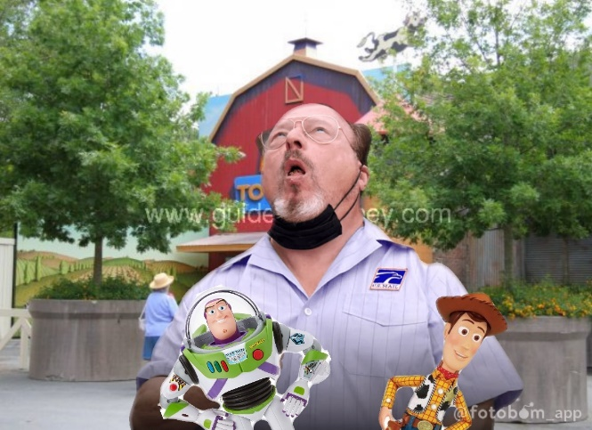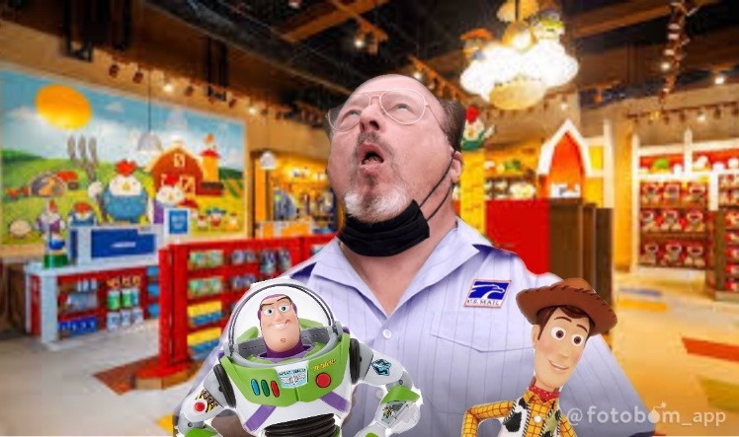
Meanwhile, when Al came inside Al’s Toy Barn store, he went in his office and put Woody and Buzz on his desk. He took each pictures of Woody and Buzz. “It’s like printing my own money,” Al chuckled to himself. Al’s cell phone rang. Al picked up and answered, “yeah? What? Oh, oh. Mr. Konishi. Yes, I have the pictures right here. It was a big pile-up, but I don’t want to bore you with the details. Yes. Now let me confirm your fax number.” While Al was on the phone, he scanned the photos to an online toy museum in Japan. “I promise the collection will be the crown jewel of your museum. Now, that I have your attention, imagine we added another zero to the price, huh?” Added Al. The man on the phone said, “yes, yes, yes. I’ll pay anything you want.” “Yes! Yes! You got a deal! I’ll be on the next flight to Japan! Don’t touch my mustache!” Al said, excitedly on the phone. After Al left his office, Woody and Buzz got up and looked around Al’s office. “Holy cow,” Woody gasped. Buzz looked at the picture of Al dressed in a chicken costume. Then, he saw the photos of Woody and Buzz photos being sold to the toy museum in Japan. Buzz said, “Woody, we’re in danger here! Al is going to sell us in the toy museum in Japan!” “Japan? No, no, no, no, no. We can’t go to Japan,” Woody gasped. “Yes, because of that chicken man!” Buzz replied, as he showed a picture of Al in the chicken costume. “That kinda looks like Al,” Woody said. “Yes, right, but we need to leave now,” Buzz said, immediately. So, they tried to leave Al’s office.
Meanwhile, Hamm looked up and saw the Al’s Toy Barn commercial again. Al announced in the commercial again, “hey kids, his is Al from Al’s Toy Barn live at Disney’s Hollywood Studios and I’m sittin’ on good deals.” “Whoah!” Rex cried. “Ow! I think I’m feeling a deal hatching right now.” Al continued. “Whoah! Let’s see what we got. We got a Pixar ball, a Buzz Lightyear, a Barbie doll, LEGOS, and Hot Wheels. buck, buck, buck! And that’s cheap, cheap, cheap! So, hurry on down to Walt Disney World…” While the commercial was still playing, Jessie told Hamm, “pause it, now! That’s where I need to go.” “You can’t go, Jessie. You’ll never make it there,” Rex exclaimed. Jessie explained, as she copied the map, “Woody once risked his life to save me. I couldn’t call myself his friend if I weren’t willing to do the same. So, who’s with me?” “I’m with you!” Said Bo. “So do I!” Potato Head said. “You can count on me!” Said Slinky. “Me!” Rex said. “I’m coming with you!” Said Hamm. “Great! Now, let’s…” Jessie tried to exclaim. But Forky interrupted by asking, “wait, what about me?” Bo said, “look, I don’t want Andy to lose you again. Now, stay here.” So, they went through the air vents to the elevator.
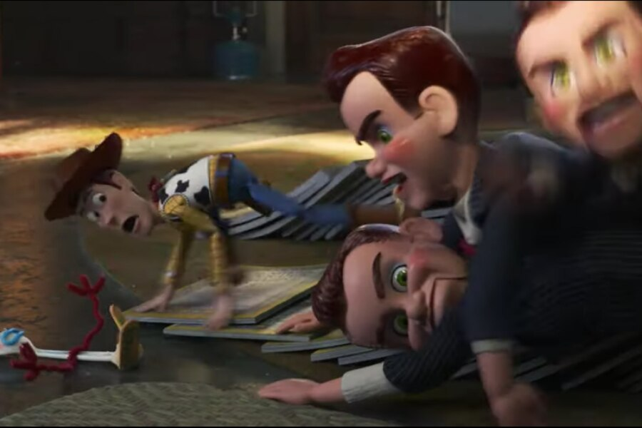
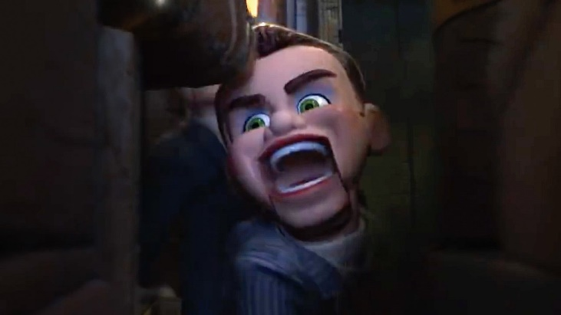
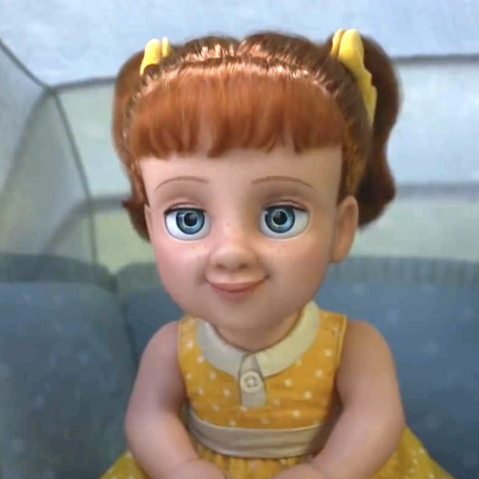
Meanwhile, when they tried to leave Al’s Toy Barn, Buzz saw a Buzz Lightyear isle. Buzz decided to look through them. “Wow!” he gasped. Woody turned around and saw Buzz walked through the Buzz Lightyear isle. “Buzz!” Woody gasped, as he tried to go get Buzz, but suddenly, a dummie pushed a mini cart toward Woody. A dummie stopped a mini cart and saw Woody. Woody chuckled, nervously, “Uh… hey, howdy. Hey there. Uh, sorry to bother you, but…” A girl doll got up and interrupted, “why, you’re not a bother at all. We were just out for my early morning stroll. And look… we met you! My name is Gabby Gabby and this is my very good friend Benson.” Woody, nervously, introduced himself by saying, “oh, uh, Woody. Pleasure to meet you.” “Well, it’s nice to meet you, Woody. Are you lost?” Gabby Gabby asked. “Lost? No, no, but we are looking for Buzz Lightyear,” Woody chuckled. “Oh, yes, I know where Buzz is,” Gabby Gabby said, happily. “You do?” Woody asked. “Hop on in. We’ll take you to him,” Gabby Gabby said. “Oh, you don’t have to do that,” Woody chuckled, nervously. “Well, okay.” Benson put Woody in a mini cart with Gabby Gabby. “Benson, be careful with our new friend,” said Gabby Gabby. While Benson pushed a mini cart, Woody tried to say with a compliment, “uh, thank you for your help, but…” Gabby Gabby interrupted by asking, “may I ask, when were you made?” “Me? Uh… I’m not sure. Late ‘50’s?” Woody cried. “Me, too!” Gabby Gabby gasped. “Gee, I wonder if we were made made in the same factory. Wouldn’t that be something? I gotta say, you are in great condition.” “Well, I try to stay active…” Woody tried to exclaim, but Benson touched Woody’s string in the back. “And look at that, you have a voice box like me,” Gabby Gabby pointed out. “Benson, show him.” “Oh, that’s really not necessary,” Woody chuckled. Benson took out Gabby Gabby’s old broken voice box to show Woody. Gabby Gabby pulled on the string. Her old broken voice box said, “I’m Gabby Gabby and I love you.” Gabby Gabby opened her voice box and showed Woody her record. She explained, “my record works just fine. It’s just the voice box that’s broken. Does yours still work?” Benson pulled onto Woody’s voice box. His voice box said, “there’s a snake in my boot!” “Listen to that! Let’s see it. I bet it’s the same type,” said Gabby Gabby. “No, thanks, mine’s sewn inside. Is Buzz around here? Because we need…” Woody tried to exclaim, but Woody saw Gabby Gabby looking at the clock for the store to be open. Gabby Gabby said, happily, “oh. The store is about to open. Don’t worry, we’ll take you where no one will see us.” “Oh, no. We can’t stay,” Woody said, immediately. “Yes, you can,” Gabby Gabby chuckled. Woody saw bunches of other dummies walking around a mini cart. “I gotta go get Buzz,” Woody said, nervously. “You can’t leave yet. You have what I need. Right inside there,” Gabby Gabby pointed out. Gabby Gabby saw a little girl walking in Al’s Toy Barn. Woody quickly got out a mini cart and ran away to find Buzz. Gabby Gabby turned around and saw Woody ran away across the store. “Stop him, please,” Gabby Gabby said, immediately. The dummies went after Woody.
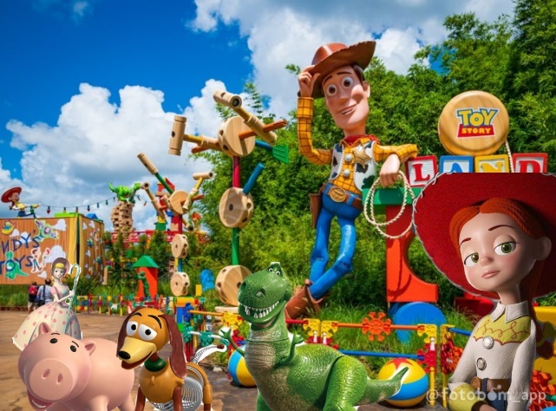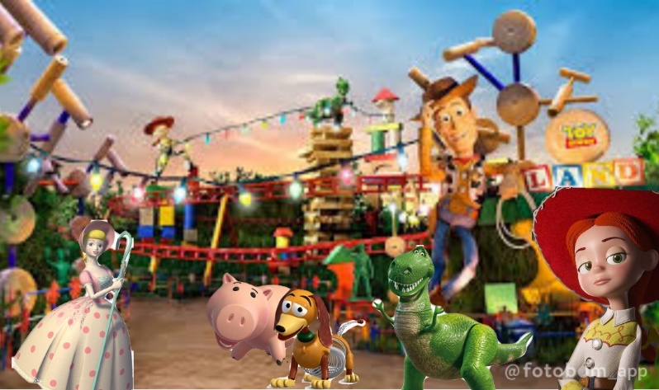
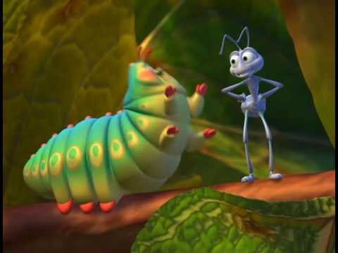
Meanwhile, a blue ant named, Flik asked a caterpillar named, Heimlich, “isn’t this exciting Heimlich? Our first day of shooting!” Heimlich said, excitedly, “oh yeah, yeah! It’s so exciting!” “You know I can’t believe that you finally talked to him into making a Bug’s Life 2,” Flik said. “Oh yeah, I can hardly believe it also, but there’s a little baby tiny thing I forgot to tell you,” Heimlich exclaimed. “What’s that, Heimlich?” Flik asked. “You know, it’s a two movie, but it’s not a Bug’s Life 2,” Heimlich explained. “Well, then, what? I’m… I don’t understand. What is it then?” Flik asked. Bo swinged her stick through the branches and even onto Flik and Heimlich! “Aaaahhh!” Flik and Heimlich screamed as they fell to the ground. “Hey, Bo, can we slow down?” Hamm asked. “May I remind you that some of us are carrying over $6 in change?” “Losing health units. Must rest.” Rex joked, exhaustedly. “Is everyone present and accounted for?” Jessie asked. “Not quite, everyone,” Potato Head said. “Who’s behind?” Bo asked. “Mine,” Slinky said, as his back came closer. Hamm saw Al’s Toy Barn on the other side. He came up with a riddle. He asked, “hey guys, how many miles do the toys can reach?” “Not now, Hamm,” Bo groaned. “Oh, I love riddles, why?” Rex asked. Hamm answered, as he pointed out, “to get to the chicken on the other side!” The toys cheared when they found Al’s Toy Barn. “Great job, Hamm. We’re that much closer to Woody and Buzz.” Jessie smiled. Jessie, Bo, Rex, Slinky, Hamm, and Potato Head walked over to Al’s Toy Barn.
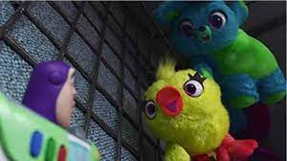
In the Buzz Lightyear isle, Buzz looked around. In the front he saw Duck and Bunny hanging on the front of the isle. Bunny said from above, “Psst, hey, Lightyear.” Duck also said from above, “hey, up here, Astroboy.” Bunny asked, “if you think you can just show up and take our top prize spot?” “You’re wrong! Dead wrong!” Duck said, angerly. “You don’t understand. I’m trying to…” Buzz tried to say sternly, but Duck interrupted to answer, “cheat the system and get with a kid? Yeah, we know.” “No, I need…” Buzz tried to exclaim, but Bunny interrupted to answer, “a child to shower you with unconditional love? Join the club, pal.” “Yeah, join the club!” Duck said, too. “Come on, can you help me and my cowboy get outta here?” Buzz asked, angerly. “Oh, I’ll help you with my foot! Oh, to infinity and my foot!” Duck joked as he kicked Buzz’s head. “How do you like that, cheater? In a galaxy far, far away, you got kicked in the head!” Buzz decided to use his helmet to grab Duck’s foot. Buzz pulled Duck and Bunny out of the price tag. Then, Buzz ran off to find Woody. “Hey, where you going?” Duck asked, sternly. “You better get over here, spaceman!” “Yeah, put us back up there!” Bunny said, angerly. “He’s getting away, let’s go!” Duck said.
Meanwhile, Woody tried to run away from the dummies. When Woody found Buzz, Buzz asked, “Woody, are you okay?” “The dummies are after me!” Woody cried. “What dummies?” Buzz asked. Woody pointed to the dummies coming into the Buzz Lightyear isle. “That dummies! Run!” Woody cried. While Woody and Buzz ran around Al’s Toy Barn, Woody exclaimed, “the dummies are with Gabby Gabby!” “Who’s Gabby Gabby?” Buzz asked. “Gabby Gabby is a creepiest doll who wants to trade my voice box to her,” Woody explained. “Does she have the voice box already?” Buzz asked, thoughtfully. “She said that her record works fine, but her old voice box is broken,” Woody continued. “Well then, we got to get out of here!” Buzz said, but then, Duck and Bunny attacked onto Buzz. “Three years!” Bunny said. “Three years!” Duck said, too. “That’s how long we’ve been hanging up there waiting for a kid!” Bunny exclaimed. “Look, I’m sorry about that,” Buzz tried to exclaim. “You ruin our lives. Shame of you!” Ducky sobbed. “Who are these guys?” Woody asked. “Lightyear promised us a kid,” Duck explained. “You did what?” Woody asked, thoughtfully. “I did not,” Buzz exclaimed, sternly. Duck and Bunny attacked Buzz. Woody tried to explain, “Alright now, come on, stop it! Cut it out now! Guys, I have a kid!” Duck gasped, “you got a kid?” “Like a kid-kid?” Bunny asked, thoughtfully. “Like a human kid, not a baby goat?” Duck asked, too. “Yeah. Now let go of Buzz and come with me. I’ll take you to Andy,” Woody said, immediately. “We’re gonna get a kid? Yes!” Duck asked, excitedly. Duck and Bunny sang, “We’re gonna get a kid!” “Alright, let’s get out of here,” Woody said.
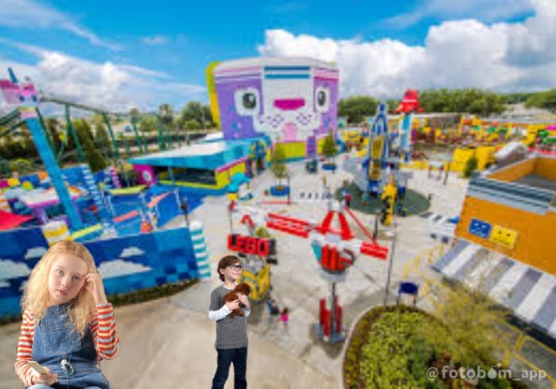
Meanwhile, Jessie and Bo pushed the cow shopping cart up in front of Al’s Toy Barn. Slinky read the sign says, “Sorry, we’re closed.” Slinky groaned, “oh no. It’s closed.” “We’re not preschool toys, Slinky. We can read.” Potato Head exclaimed. The toys saw a shopkeeper walked up to the automatic slide doors and it slid open. “Alright. You have to follow my lead. We stay together, we stay quiet. Let’s go,” Bo said, immediately. As the toys hopped out of the cow shopping cart, Rex exclaimed, “but the sign says it’s closed.” Each of the toys tried to stomp their feet to open the automatic slide door, but Jessie said, immediatelty, “no, no, no, no. All together. Now!” So, they all stomped their feet and the automatic slide door slid open. The toys ran inside before the automatic slide door slid closed. They could see the whole inside of Al’s Toy Barn. “Whoa, Nelly!” Slinky gasped. “How are we going to find Woody in this place?” Jessie answered, “Look for Al. We find Al, we find Woody. Now move out!” Hamm saw Woody, Buzz, Duck, and Bunny ran through the isle. He shouted, “Woody!” Bo looked on the other isle and called out, “Buzz?” “No, I see Woody and Buzz!” Hamm said, correctly. Woody, Buzz, Duck, and Bunny ran up to Jessie, Bo, Rex, Slinky, Hamm, and Potato Head. Buzz said, happily, “Jessie! It’s good to see you again!” “Bo!” Woody said, happily, too. “What are you two doing here?” “Long story,” Woody sighed. “Al picked us at Pizza Planet and then he took us to Al’s Toy Barn to sell us in a toy museum in Japan!” “Japan? “No, you can’t go to Japan,” Jessie gasped. “I know, but when we leave, there’s a creepy doll named, Gabby Gabby, who wants to use my voice box, and…” Woody tried to explain, but suddenly, Gabby Gabby came in front and interrupted, “hello, Woody. I just wanna talk.” “Yeah, with my voice box,” Woody said, angerly. “Woody, let’s go!” Buzz gasped. Woody tried to run with Buzz up to Bo, Jessie, Rex, Slinky, Hamm, and Potato Head, but the dummies grabbed Woody and took him away back to Al’s office. “Woody!” Jessie cried. “I can’t watch! Can someone cover my eyes?” Rex cried. “Where are they going?” Slinky asked. “He’s taking Woody back to Al’s office!” Buzz gasped. “Alright, we need to think of a plan to save Woody,” Bo said, immediately. “But how do we do that?” Slinky asked. Bo said her plan, “Buzz, since you’re a toy, use your lazer and your karate chop action! Slinky swing Gabby Gabby around so that they don’t move. Jessie, get the tape and tie them up. Hamm, put them in the box. Are we clear?” “Absolutely,” Buzz said. Although, Bunny asked, “now, hold on. I have a question. Can we do this?” (Imagination scene: Al saw Duck and Bunny sitting on the shelf. Duck and Bunny attacked Al!) “Well, we’re not doing that,” Buzz groaned. “Yeah, yeah, I agree, too visible,” Duck said. “It’s a good point. Something more subtle,” said Bunny. “Ooh, what about winner, winner, chicken dinner?” Duck asked the suggestion. (Imagination scene: Duck and Bunny rolled the baseball to the floor. Al looked underneath the desk and suddenly, Duck and Bunny attacked Al!) “Uh… you’re kidding,” Buzz joked. “Okay, okay. Well… oh, what about the old Plush Rush?” Bunny asked the suggestion. (Imagination scene: Al packed up his stuff and left Al’s Toy Barn to drive home. While Al was asleeping, Duck and Bunny snuck onto Al’s bed! Al screamed.) “Not going to happen. N-O,” Buzz said, immediately. “Okay, guys. Playtime is over. Just follow my lead. Got it?” Bo said, sternly.
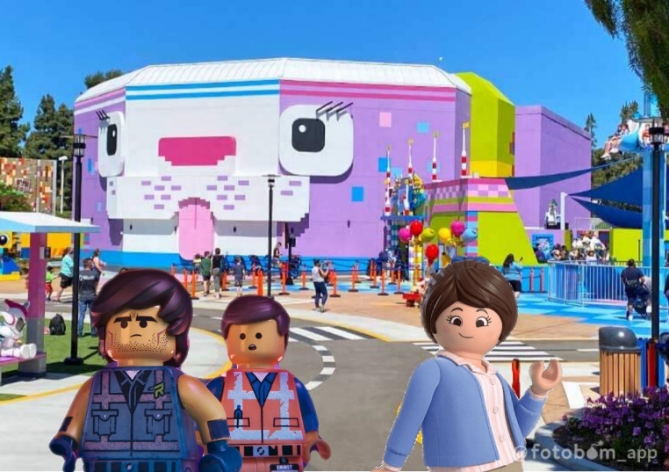
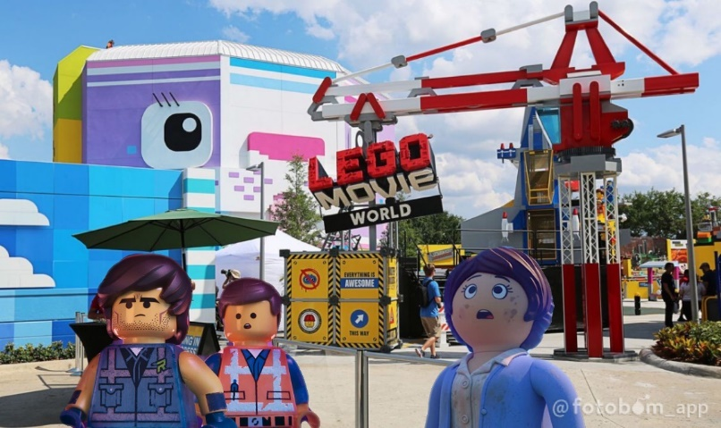
Meanwhile, when Andy, Molly, and their parents arrived at LEGOLAND Florida, Andy took a backpack with the LEGO Minifigures inside with him. “Well, here we are. LEGOLAND Florda,” the dad said. “So where do you want to go first?” the mom asked. Andy said the plan, “First, I want to go to The LEGO Movie World and then…” While Andy was talking, Emmet, Lucy, and Rex peaked out the zipper to see LEGOLAND Florida. Rex gasped, “This is incredible! What is this place?” This is LEGOLAND Flordia,” Lucy answered. “Isn’t that awsome?” Emmet asked. “Yes it is, Emmet, but I never been to LEGOLAND before,” Rex said. “That’s because you’re a new LEGO toy and a master builder,” Lucy explained. “How am I a master builder?” Rex asked. Emmet explained, “It’s easy, you can build any LEGO Bricks however you want rather than following the instructions, but Lucy, I’m a little worried about Marla and Charlie. How are they doing?” Lucy looked around and saw Charlie hopping off the backpack. “Uh, Emmet?” Lucy cried. Emmet turned around and heard Marla called out, “Charlie, no!” Marla tried to save Charlie but she fell off the backpack too. Emmet asked, “Unikitty, where is Andy going to walk up to?” “The LEGO Movie World, give or take,” Unikitty answered. “Looks like we’re going to save Marla and Charlie,” Rex smiled. “Come on!” “No!” Lucy cried. Both Emmet and Rex hopped off the backpack.
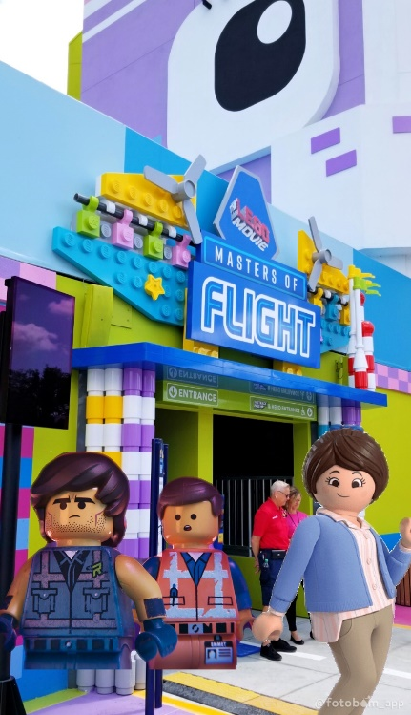
When Emmet and Rex got up, they saw that Andy, Molly, and their parents walked to The LEGO Movie World without them. Emmet cried to himself, ““Doesn’t he realize that I’m not there? I’m lost! Oh, I’m a lost LEGO toy!” Emmet began to cry. Rex came over and asked, “are you okay there, pal?” “No, we’re lost and Andy’s gone because…” Emmet tried to exclaim, but then, he forgot to ask, “where’s Marla and Charlie?” Emmet and Rex saw Charlie looking all around LEGOLAND Florida. He gasped to himself, “Wow! This place is amazing!” Marla found Charlie and dragged him to Emmet and Rex. She tried to say immediately, “Charlie, there’s no time to explore other places you got to stay…” Then, she saw Emmet and Rex standing there without Andy, Molly, and their parents. “Where’s that giant kid?” Marla asked. “You mean Andy?” Emmet explained. “Oh, uh, he just went to The LEGO Movie World without us because you and Charlie just jumped out of his bag and now, we’re lost.” “It wasn’t my fault. Charlie is the one who jumped off the bag,” Marla exclaimed. “Come on, Emmet. I was just exploring this huge LEGOLAND Florida. Can we go to The LEGO Movie World first?” Charlie asked. “Uh, The LEGO Movie World is that way!” Rex pointed out. “Come on guys. We got to get to Andy,” Emmet said, immediately.
When Emmet, Rex, Marla and Charlie walked into The LEGO Movie World, they explored all over the attraction. Emmet gasped, “awesome!” “So, where is Andy going to first?” Charlie asked. “He’s heading into Master of Flight! Let’s go!” Emmet pointed out. When Emmet, Rex, Marla, and Charlie walked inside Master of Flight, Emmet saw Emmet on the TV screen teaching the customers how to ride on the Master of Flight. Emmet gasped, “that’s me!” After the instructional video is over, Charlie asked, “Emmet?” “Yes, Charlie?” Emmet replied. “When Andy put his backpack in the storage area, can we climb back inside?” “Yeah, that’s what I said in this instructional video,” Emmet answered. “You said that?” Marla gasped. “No, no. What I mean is that another Emmet on the instructional video told Andy to put his backpack in the storage area,” Emmet explained. “We understand,” Marla said. “Well then, let’s go find where Andy’s backpack is,” Rex said, happily.
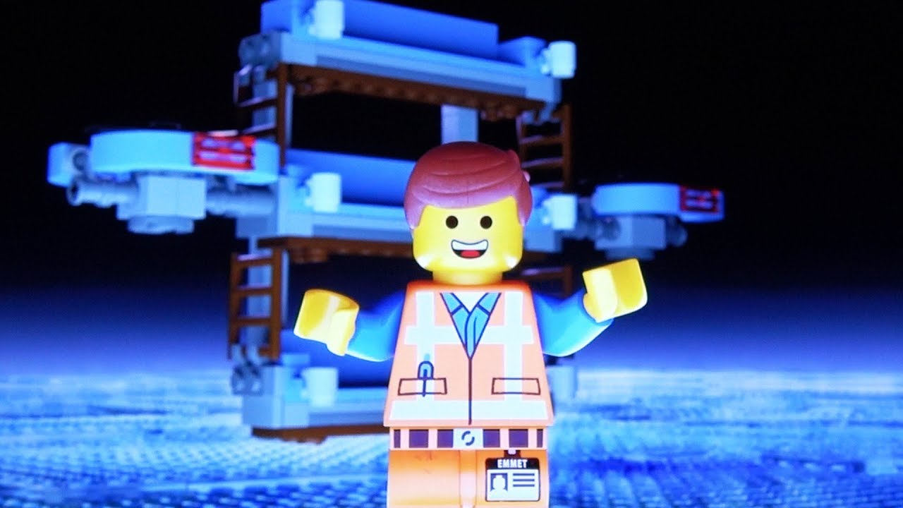
Meanwhile, Andy put his backpack in the storage area. While he was getting on his seat of the Master of Flight, Lloyd asked to himself, “I don’t know why Emmet, Rex, Marla and Charlie just hopped out of this backpack?” “Yeah, they ain’t coming back!” Batman said, sternly. Lucy thought to herself. She looked at the LEGOLAND Florida map. Lucy had an idea. She said, “Benny, you go make a list of places for Andy, Molly, and their parents to go to in order.” “What?” they gasped. “I’ll go find Emmet and meet you at the LEGO theater, where they play The LEGO Movie 4D: A New Adventure at the end. Got it?” Lucy said. “You got it!” Benny said. Lucy hopped out of the backpack to find Emmet. Meanwhile, Emmet, Rex, Marla and Charlie walked inside and saw Andy, Molly, and their parents hopping on to their seats of the Master of Flight. “Do you see them?” Marla asked. Emmet pointed out, “there they are!” Suddenly, the Master of Flight started to run. Emmet, Rex, Marla, and Charlie looked underneath the seats and they imagined that they’re flying on the Master of Flight. Emmet said, happily, “now this is flying with style!” “Where did you learn that?” Rex asked. “Oh, my old friend, Buzz Lightyear liked to say that whether he’s really flying or falling with style,” Emmet explained. “This sounds so much fun!” Charlie said, excitedly, right when he leaned off the rail. Marla saw that Charlie was about to fall off. She said, immediately, “Charlie, wait! You’ll fall out. I don’t want to lose you again.” “I’m having fun!” Rex said, excitedly, “will Lucy come ride with us?” Emmet saw Lucy coming toward Emmet. “Lucy?” Emmet asked, thoughtfully. “Yeah, Lucy,” Rex replied. “Emmet!” Lucy said, happily. “Lucy!” Emmet said, happily, too. “I’m so glad that you found us!” “Yes, but come on! Andy is about to leave and we need to get on the backpack,” Lucy exclaimed. Lucy, Emmet, Rex, Marla, and Charlie rushed over to the storage area and they saw that Andy’s backpack was gone. Lucy saw Andy carrying his backpack and leaving the Master of Flight with Molly and his parents. “Over there!” Lucy called out. Emmet, Lucy, Rex, Marla, and Charlie left Master of Flight to go find Andy.
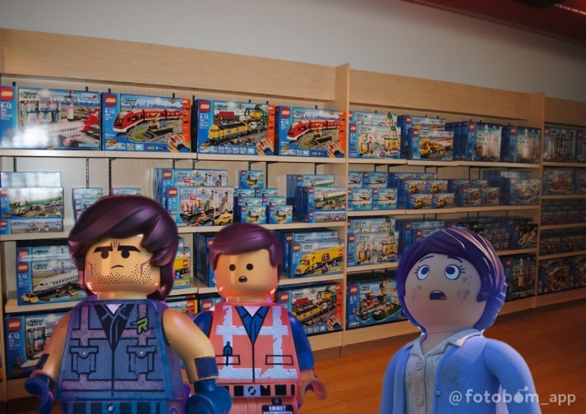
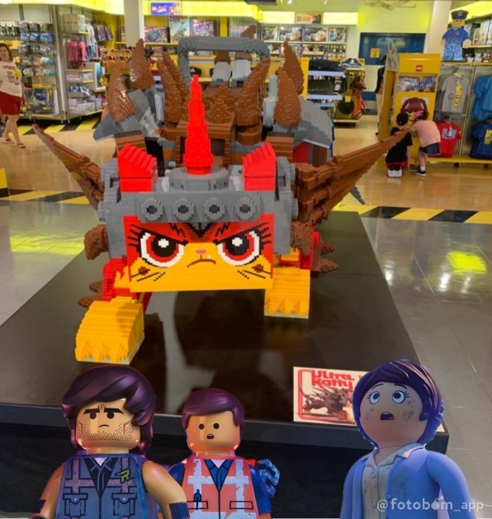
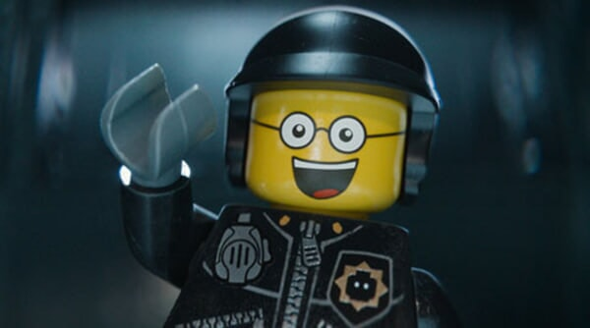
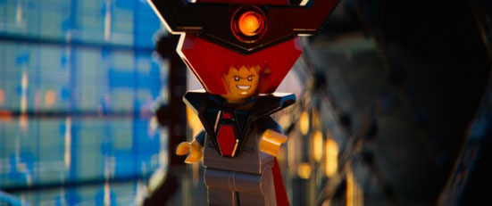
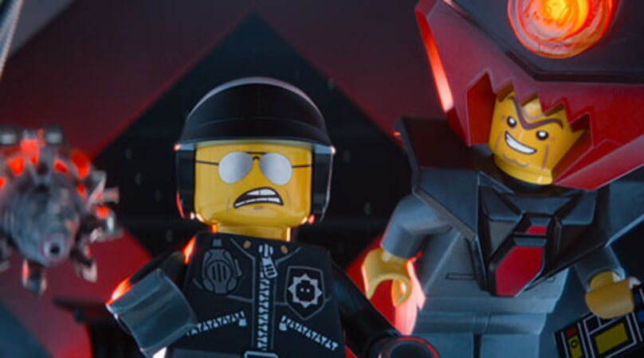
When Emmet, Lucy, Rex, Marla, and Charlie left The LEGO Movie World, Emmet asked, “now where are they going?” Lucy saw Andy, Molly, and their parents walked into the big shop. She said, “they’re heading in the big shop!” When they came up to the big shop, Marla gasped, “wow!” “This is the biggest store I ever saw!” Charlie gasped, too. “Quick, inside!” Lucy called out. When Lucy, Rex, Emmet, Marla, and Charlie came inside the big shop, Emmet gasped, “holy cow!” “Look at all of those stuff,” Rex gasped, too. “So, where are we going to find Andy in here?” Charlie asked. Suddenly, a police officer stood in front of Emmet and Rex, looking evil and impatient. He was one of those Bad Cops, the kind Emmet and Rex preferred to avoid. Bad Cop handcuffed both Emmet and Rex and then put them in the two chairs in front of the Angry Unikitty LEGO statue. “What’s happening?” Emmet asked, thoughtfully. “What’s going on?” Rex asked, thoughtfully, too. “What are you two doing here?” Bad Cop, asked, angerly. “We’re looking for a kid,” Rex answered. “A giant kid? You can’t go find a giant kid,” Bad Cop said, angerly. “You two are under arrest, but Lord Business would be so pleased to see you as a master builder.” “But I’m a master builder,” Emmet replied. “You’re a lier!” Bad Cop shouted as he threw a chair across the room. “Look, I watch a lot of cop shows on TV,” Rex said. “Isn’t there supposed to be a good cop?” Emmet asked. “Oh, yeah, but we’re not done yet,” Bad Cop said as he spun his head around to reveal a Good Cop face he’d been hiding on the back. “Hi buddy!” Good Cop smiled. “I’m your friendly neighborhood police officer. Would you like a glass of water?” Emmet grinned, “yeah, sure, actually…” The Good Cop’s head swung around to his Bad Cop face again. He said, angerly, “too bad!” Emmet and Rex gasped as they saw Bad Cop knocked the glass of water out of his hands. “Now, Lord Business is coming. Cover your butt,” added Bad Cop. “Cover your what?” Rex asked, thoughtfully. An instant later, a tall, dark Minifirgure in a cape and helmet walked behind the Angry Unikitty LEGO statue. “Lord Business,” Emmet gasped as he stared at him. “Gwa ha ha ha ha! If it was the only one of the greatest and most important special person in the history of the universe, Emmet Brickowski. My master builder,” Lord Business said with his evil laugh. “So, where’s that old man, Vitruvius?” “Oh, uh… Vitruvius is back at our home,” Emmet exclaimed. “What?! He's back at home?!” Lord Business shouted, angerly. “Well, I mean is that we have a kid named, Andy Wendy who took us on a vacation to Orlando,” Emmet explained. “So, now we’re in LEGOLAND Florida, but we’re trying to find my friends.” “You brought friends to LEGOLAND Florida with you?” Lord Business asked. “Well, I shall capture your friends, but first, I unlock the most powerful super weapon, the Kragle!” “The Kragle?” Rex gasped, thoughtfully. “Bad Cop, destroy them!” Lord Business told Bad Cop, angerly. “Aargh! I’ll take you to the melting chamber!” Bad Cop growled as he dragged Emmet and Rex to the melting chamber. “What? You’re going to melt me?” Emmet gasped. “Am I going to die?” Rex gasped too. Bad Cop spun his head around to the Good Cop side. “You’ll live. You’ll be fine,” Good Cop smiled. The Good Cop head swung back around to the Bad Cop side. “President Business, I have them right here, sir. I told him he’ll live so he doesn’t try to escape, but um… we’re lying to him,” added Bad Cop. “Wait, what did he just say?” Rex cried. “Hold still, you both Master Builders!” Lord Business said, as he pulled the lever on the rack’s control, activating a laser. “Wait!” Emmet called out.

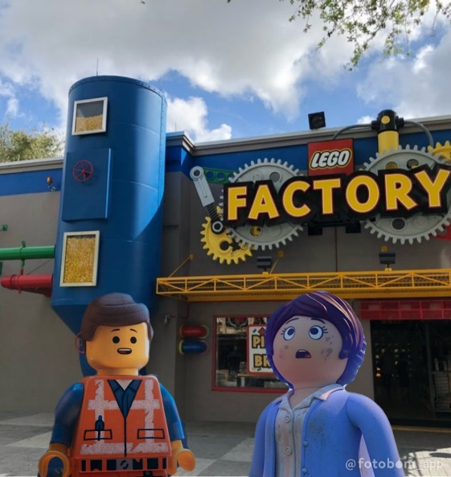
Suddenly, Lucy, Marla, and Charlie burst into the room. Lucy dashed over to Emmet and Rex, swinging an axe to broke off his chains, freeing them. “Lucy?” Emmet asked, thoughtfully. “It’s you!” Rex said, happily. “Come with me if you wanna not die,” Lucy told them. Lucy grabbed both Emmet’s hand and Rex’s hand. Lucy, Rex, Emmet, Marla, and Charlie ran out of The Big Shop and across toward the LEGO Factory. Inside the LEGO Factory, Lucy, Emmet, Rex, Marla, and Charlie looked around. “Whoah, this is incredible!” Rex gasped. “What is this place?” Charlie asked. Lucy stood on top of the LEGO bin. She announced, “Welcome to the LEGO Factory! A factory where they make LEGOs!” “Wait just a minute, there’s already a factory where they make LEGOs in Denmark,” Emmet exclaimed. “No time to explain. Lord Business and Bad Cop are coming in the LEGO Factory. Look!” Lucy pointed out. Emmet, Rex, Marla, and Charlie turned around and saw Lord Business and Bad Cop came into the LEGO Factory. “Ah ha! The LEGO Factory. A factory where we can create Kragle and destroy those Master Builders,” Lord Business said with an evil smile. “Bad Cop, put them on the conveior belt and destroy them!” “What should we do now?” Marla asked. “We’ll build a motorcycle out of the LEGO Factory,” Lucy told Marla. “So, you know where to get all of those pieces to build a motorcycle from this LEGO Factory?” Emmet asked, thoughtfully. Lucy looked around and grabbed LEGO pieces. Then, she built a motorcycle together without thinking about it. Lucy had finally completed her creation. She hopped on and revved the engine. Rex, Marla, and Charlie hopped on the back of the bike. “Jump on! Let’s go!” Lucy said as she grabbed Emmet. “Aaaahhh!” Emmet screamed until Lucy tossed him onto the back of the bike. They squealed out of the LEGO Factory. Lord Business became so mad in fact, he said, angerly, “we’ve lost them! How are we going to catch up onto them now?” Bad Cop looked around and grabbed more LEGO pieces. Then, he built a Super Secret Police Car together without thinking about it. Bad Cop had finally completed his creation. “Climb aboard, President Business!” Bad Cop told him. Lord Business hopped onto the Super Secret Police Car. They squealed out of the LEGO Factory and went after Emmet, Lucy, Rex, Marla, and Charlie.
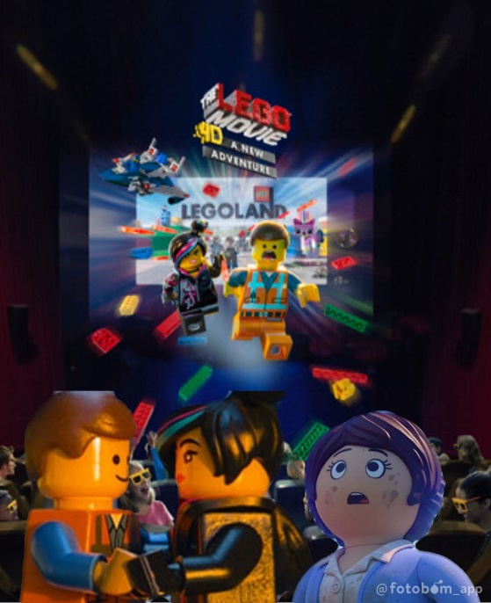
Meanwhile, Emmet, Lucy, Rex, Marla, and Charlie rode on the motorcycle through the LEGOLAND Florida theme park to find Andy. “Now, can we go find Andy?” Emmet asked. Lucy saw the LEGOLAND Theater. Lucy pictured the list on the map of where Andy, Molly, and their parents go in order. She said as she pointed out, “I have a feeling that Andy is in that theater.” So Emmet, Rex, Lucy, Marla, and Charlie rode the motorcycle into the LEGOLAND Theater. Meanwhile, after Andy, Molly, and their parents walked to their seats in the LEGOLAND Theater, inside Andy’s backpack, Batman gasped, “Dang it, they’re about to miss the LEGO Movie 4D: A New Adventure.” Lloyd saw Emmet, Lucy, Rex, Marla, and Charlie rode their motorcycle underneath the seats. He said, “no, wait! Here they come, now!” “Emmet! You made it!” Benny said, happily. “You’re just in time to see the LEGO Movie 4D: A New Adventure! Come on!” Emmet, Rex, Lucy, Marla, and Charlie hopped back in his backpack. So Emmet, Lucy, Rex, Batman, Lloyd, Benny, Unikitty, Marla, and Charlie watched the LEGO Movie 4D: A New Adventure. They enjoyed seeing it until suddenly, Bad Cop and Lord Business rode the Super Secret Police Car underneath the seats and found them. “Lord Business,” Emmet gasped. “Bad Cop,” Lucy cried. “Finally, I got where I want you. I bought the Kragle over at the LEGO Factory for Bad Cop to freeze you right here,” Lord Business said, angerly as he handed the Kragle to Bad Cop. “Enough of this getting away. Go ahead, Bad Cop. Finish the job.” “Of coarse, sir,” said Bad Cop. His face spun from Bad Cop to Good Cop. “No, I don’t want to,” Good Cop whispered. His face spun back to Bad Cop. “You have to…” he muttered to himself. Then Good Cop was back. “I don’t want to…” he whispered. “Would you please be quiet?” Bad Cop asked, angerly. “I can’t…” said Good Cop. “You must!” Bad Cop commanded. “But it’s not nice…” Good Cop protested. “It’s your job!” Bad Cop insisted. The head spun back to stick with the Good Cop side. “I can’t do it. They’re innocent,” Good Cop insisted. “Just as I thought,” Lord Business said, sternly. “Your Good Cop side is making you soft, Bad Cop.” Lucy explained, “I think Good Cop doesn’t want to be a Bad Cop and you don’t have to be a bad guy. You might see a mess, but look at all of those people built.” “Yeah, exactly and a bunch of really weird and dorky stuff that ruined my perfectly good stuff!” Lord Business groaned. “Okay, but I see are people inspired by each other and by you. People taking what you made and making something new out of it,” Emmet explained too. “You are the most talented, most interesting, and most extraordinary person in the universe and right now it’s about you. You can still change everything. You are special, so is everyone and so am I.” Lord Business’s eyes filled with tears. Then, he approached Emmet slowly and hugged him! “Oh, we’ve got a hugger,” Emmet chuckled. “So now, will you join us?” Lucy asked. Lord Business and Good Cop hopped in Andy’s backpack. After the LEGO Movie 4D: A New Adventure is over, Andy forgot about Emmet, Lucy, Rex, Marla, and Charlie. He cried, “oh, I forgot to show Emmet, Lucy, Rex, Marla, and Charlie the LEGO Movie 4D: A New Adventure! Where are they?” “Did you check your backpack?” the Mom asked. Andy looked at his backpack and saw the rest of the LEGO Minifigures and 2 Playmobil toys are still in his backpack. Andy said, happily, “oh wait, they’re still there.” The Mom said, happily, “see, I knew that they saw the LEGO Movie 4D: A New Adventure too.” “And, we’ll have time tonight to go to the lost and found to find Woody and Buzz! Come on!” The dad smiled.
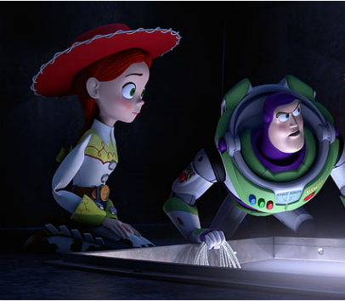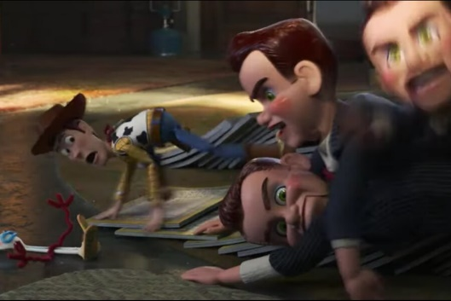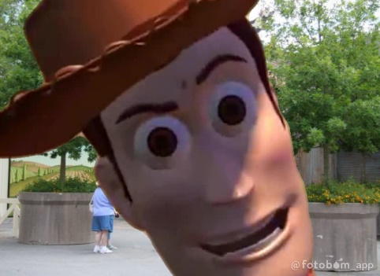
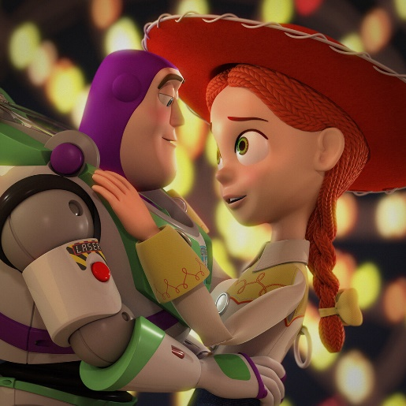
Meanwhile, back at Al’s Toy Barn, above the air vent, Buzz, Jessie, Bo, Duck & Bunny, Rex, Slinky, Hamm, and Potato Head saw the dummies put Woody underneath the sewing machine. Inside Al’s office, Gabby Gabby told Woody, “I knew you’d be back.” “You don’t know me,” Woody said, angerly. Then, Woody saw Buzz, Jessie, Bo, Duck & Bunny Rex, Slinky, Hamm, and Potato Head above the air vent. Woody had a cheaty idea. “I just wanna talk,” Gabby Gabby said, kindly. “Yeah, with my voice box! Pull on it!” Woody said, sternly. Bo saw Gabby Gabby was about to pull onto Woody’s pull-string to pull out Woody’s voice box. Bo cried, “Woody, no!” When, she pulled onto Woody’s pull-string, the voice box said, “Reach for the sky!” As Gabby Gabby kept pulling the pull-string out as hard as she can, the voice box automatically said, “This town ain’t big enough for the two of us.” “What?” Gabby asked, thoughtfully. Buzz, Jessie, Bo, Duck & Bunny Rex, Slinky, Hamm, and Potato Head above the air vent were confused. “There’s the snake in my boot!” Woody voice box automatically continued. “That’s busted,” Gabby Gabby groaned. “Who are you callin’ busted, buster?” Woody’s voice box automatically asked. “That’s right. I’m talking to you, Gabby Gabby.” “How could your voice box talk by itself?” Gabby Gabby gasped. The other dummies gasped too. Bo realized what Woody is doing. She had a better idea too. “We don’t like to be smashed or ripped apart, Gabby Gabby,” Woody’s voice box automatically continued. “We?!” Gabby Gabby cried. “That’s right! Your toys!” Woody’s voice box continued. Suddenly, Buzz, Jessie, Bo, Duck & Bunny Rex, Slinky, Hamm, and Potato Head jumped down into Al’s office. Jessie hid behind Buzz. Jessie said, “Buzz, do something quick!” “Sheid your eyes,” Buzz said as he buzzed the lightbulb lazer at Gabby Gabby, but didn’t really hurt her. She said, “ooh, nice lazer. Could that stop us?” “It’s not working. I recharged it before I left. It should be good for…” Buzz said, thoughtfully, but Jessie interrupted by saying as she pressed the karate chop action, “you idiot! You’re a toy! Use your karate chop action!” “Hey! Hey! How’re you doing that?” Buzz gasped as he karate chopped Gabby Gabby. Next, Slinky wrappped around Gabby Gabby and the dummies. “Hey!” Gabby Gabby gasped. “Go get the tape!” Slinky told Rex. Rex dashed across the desk. He grabbed the end of a roll of tape and rushed toward Gabby Gabby and the dummies. Together, they managed to wind the tape around Gabby Gabby and the dummies. When Buzz, Jessie, Bo, Duck & Bunny, Rex, Slinky, Hamm, and Potato put Gabby Gabby and the dummies tied up in front of the box, Woody stood in front and his voice box automatically said, “from now on, you must take good care of your toys because if you don’t, we’ll find out, Gabby Gabby. We toys can see everything.” Then, Woody said, angerly, “so play nice.” “Aaaahhhh!” Gabby Gabby and the dummies screamed as they ran up to the box. Jessie taped the lid of the box, so that they won’t get out. Bo signed the sticky note that says, “To the toy museum in Tokyo, Japan.” “Ha-ha! We did it! We did it! Ha-ha! Yes!” Woody said, happily. Woody, Buzz, Jessie, Bo, Duck & Bunny, Rex, Slinky, Hamm, and Potato Head cheered. “Nice work, fellows. Good job,” added Woody. “Woody, thanks,” Buzz said, as he shook Woody’s hand. Suddenly, Woody heard Al coming into his office. He gasped, “it’s Al!” Woody, Buzz, Jessie, Bo, Duck & Bunny, Rex, Slinky, Hamm, and Potato Head hid underneath Al’s desk. Al came in and said to himself, “look at the time. I’m gonna be late! Figures. I can’t miss this flight! I’ve gotta pack.” Al loaded the box with Gabby Gabby and the dummies on the dolly. “Alright, let’s see. Wallet, keys, tickets, passport, beef jerky, very expensive over there. Shower? Oh, I can skip the shower. I just gotta get outta here now!” Added Al, as he left Al’s office. “Happy trails, Gabby Gabby,” Woody smiled. “Quick! Let’s go back to the Toy Story Hotel!” Buzz said, immediately.
Woody, Buzz, Jessie, Bo, Duck & Bunny, Rex, Slinky, Hamm, and Potato Head ran out of Al’s office. Woody saw the automatic slide doors all the way in the front of the store. He said, “here’s the way out!” “How are we going to get all the way over there?” Slinky asked. Buzz saw the baseball bats in front of the isle, the trampoline on the next isle, and five monkeys on the high wire on top. Buzz figured out how to get there faster. He said as he climbed up the tags, “climb aboard!” “Buzz, what are you doing?” Woody asked, thoughtfully, but Woody, Jessie, Bo, Duck & Bunny, Rex, Slinky, Hamm, and Potato Head climbed up the tags too. The toys, took each baseball bat to lean toward the trampoline. They bounced on the trampoline and they rode on each of the high wire monkeys. Buzz could see Al walking out of the automatic slide doors. He told Woody, Jessie, Bo, Duck & Bunny, Rex, Slinky, Hamm, and Potato Head, “get ready to jump!” The toys jumped off their high wire monkeys to make it out of Al’s Toy Barn, but then, the automatic slide door slid closed and they slid down to the ground. “Great!” Woody groaned. Then, Jessie remember how they got into Al’s Toy Barn in the first place. She asked, “wait a second, remember how we got into Al’s Toy Barn together?” “I don’t remember how we got into Al’s Toy Barn, Jessie,” Woody groaned. “We all stomp together to make those doors slide open,” Jessie exclaimed. “Good idea, Jessie! All together. Now!” Buzz told Woody, Jessie, Bo, Duck & Bunny, Rex, Slinky, Hamm, and Potato Head. So, they all stomped their feet and the automatic slide door slid open. The toys ran out of Al’s Toy Barn before the automatic slide door slid closed.
“We made it!” Jessie said, happily. “Let’s go back to the Toy Story Hotel,” Woody said. Right when Woody, Jessie, Bo, Duck & Bunny, Rex, Slinky, Hamm, and Potato Head were on their way back to the Toy Story Hotel, Jessie saw Andy, Molly, and their parents walking back into Disney’s Hollywood Studios. Jessie told Woody and Buzz, “Wait! Andy’s coming!” “What?” The toys gasped. “Wait a minute, we should all be in Andy’s backpack,” Buzz said. “No, we all can be in Andy’s backpack. It will be too heavy for us go back,” Jessie explained. “But, Jessie…” Woody cried, but Bo put her hand onto Woody’s shoulder and said, “Jessie’s right. Andy is looking for you and Buzz. We’ll meet you back at the Toy Story Hotel.” “Are you sure?” Woody asked. “We’ll all be together,” Bo replied. “Okay… meet you all back at the Toy Story Hotel,” Woody said as he hugged Bo and Jessie. Bunny told Buzz, “hey… uh, so long, Astroboy.” “See you at the Toy Story Hotel,” Buzz said too. Duck and Bunny hugged Buzz tightly. When Buzz and Woody walked up front, they froze. Jessie, Bo, Rex, Slinky, Hamm, Potato Head, Duck and Bunny saw when Andy walked up front, Andy said, happily, “hey wow!” “What is it?” the Dad asked. “Woody! Buzz!” Andy said, happily, as he picked them up. “Oh, great, you found them,” the Mom smiled. “I can see that they’re next to Toy Story Mania ride. Can Andy take them on that ride?” Molly asked. “Well, uh… of coarse he can, but as long as they don’t go on a roller coaster,” the dad said. Andy took Woody and Buzz into Toy Story Mania ride again with Molly and their parents. Bo smiled, “have fun, sheriff.” Jessie told Bo, “quick, let’s head back to the Toy Story Hotel!” Jessie, Bo, Rex, Slinky, Hamm, Potato Head, Duck and Bunny went back to the Toy Story Hotel.
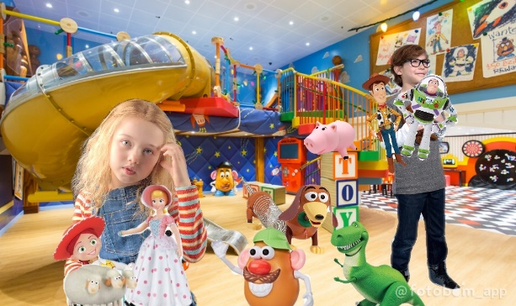
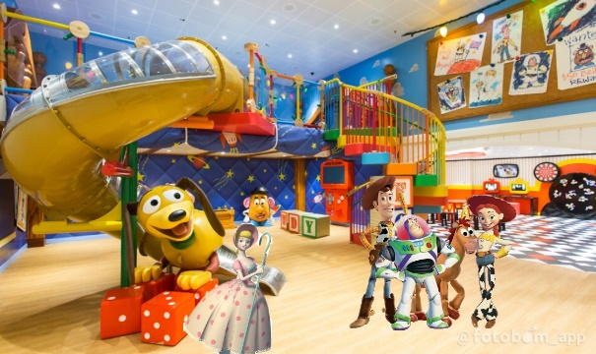
Later that night, back at the Toy Story Hotel, Andy, Molly, and their parents walked back to their room. Andy saw 4 new toys. “Oh, wow! New toys! Cool! Thanks, mom!” Andy said, happily, as he played with his 4 new toys. Then, the mom called out, “Andy! Molly! Time for bed!” Andy put his backpack back next to the bed. When, Woody and Buzz got out, they saw the toys, the LEGO toys, and 2 Playmobil toys back together again. Jessie asked, “so how was Toy Story Land?” Bo also asked, “did you two have fun?” “Jessie! Bo!” Buzz and Woody said, happily. Buzz hugged Jessie and Woody hugged Bo. Woody forgot about Forky. He asked, “wait, where’s Forky?” “He’s right over there,” Jessie pointed out. “Woody!” Forky said, happily, as he hugged Woody. “So happy that you’re safe, Forky,” Woody smiled. Buzz saw Emmet, Lucy, Rex, Benny, Batman, Lloyd, Unikitty, Marla, and Charlie in the back. Buzz asked, “Emmet, you guys are back! How was LEGOLAND?” “Awsome!” Emmet said, excitedly. “Were Marla and Charlie okay?” Woody asked. “There safe with us,” Lucy said. “LEGOLAND was huge!” Charlie said. “Wait a minute, who are those LEGO toys?” Buzz asked. “I would like for you to meet President Business and Good Cop!” Lucy introduced them to Buzz. “Hi buddy!” Good Cop smiled. “I’m your friendly neighborhood police officer. Would you like a glass of water?” “Aww, that’s very sweet of you,” Buzz smiled. Rex the T-Rex came over to Woody and asked, “so, Woody, how long are we going to be in Orlando?” “Just for a week until we’re back home for plenty of time for Christmas,” Woody answered.
Epologue
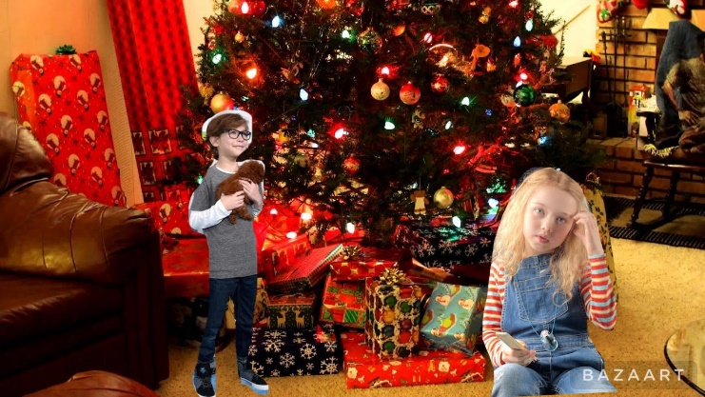
Soon, it was Christmas. Andy, Molly, and their parents were back home. The toys, and the LEGO Minifigures were happy that they’re back home too. While Andy and Molly open their presents, the LEGO Green Army Man saw what Andy was about to open. He went over to the walkie talkie and called for the LEGO Minifigures.
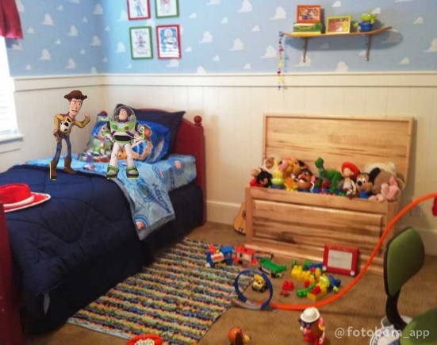
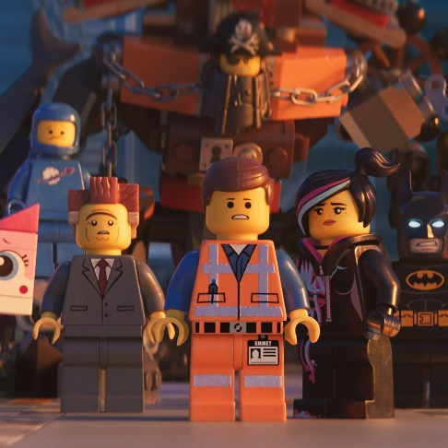
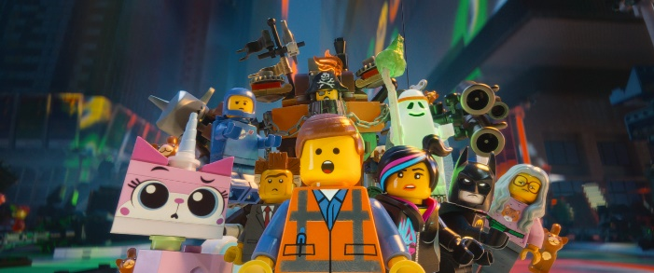
Meanwhile, down at the basement, the LEGO Minifigure Master Builders gathered around Bricksburg to hear on the walkie talkie. Vitruvius stood next to the walkie talkie. Vitruvius called out, “hey, heads up everybody. It's show time.” “Whoah! It’s about time!” Batman said, excitedly. Emmet walked over to hear what present is Andy opening, but Lucy pulled Emmet’s hand out. Emmet cried, “my hand!” “Oh, I’m sorry. Here’s your hand back,” Lucy said, as she gave Emmet his hand back. “I just want stand right here and say, Merry Christmas, Emmet.” “Wait a minute, is that mistletoe?” Emmet asked. Lucy gave Emmet kisses. “Andy is opening his first present now,” the LEGO Green Army Men said on the walkie talkie. Rex was waiting patiently for Emmet and Lucy to get back. He called out, “where are you, Emmet?” Emmet and Lucy came back. Emmet asked, “is Andy opening his first present now?” “Quiet, Emmet!” Lucy said, immediately. The LEGO Green Army Men announced on the walkie talkie, “Andy’s first present is LEGO: The Adventures of Clutch Powers set.” “Now, I have 3 special Master Builders of the universe!” Emmet said, excitedly. The LEGO Green Army Man announced on the walkie talkie, “Molly’s opening a large box… It’s-it’s-it’s…” “I wonder Woody and Buzz know which present Andy’s opening?” Lucy asked, thoughtfully. “Oh, we have nothing to worry about. They’ll get something better, “Emmet smiled. “In fact, Molly’s opening her big present. Oh, what will Molly possibly get that is worse than Rex?” Molly on the walkie talkie shouted, “oh, what is it? It’s LEGO Duplo!” “Oh, man!” Emmet gasped.
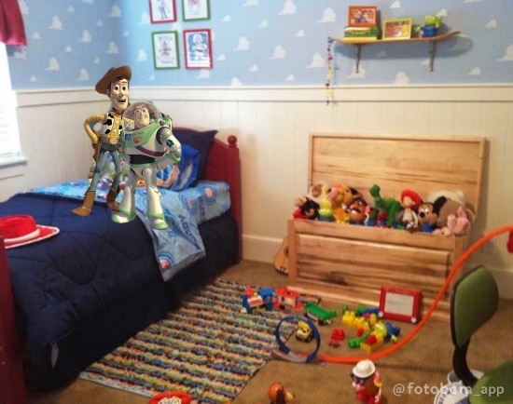
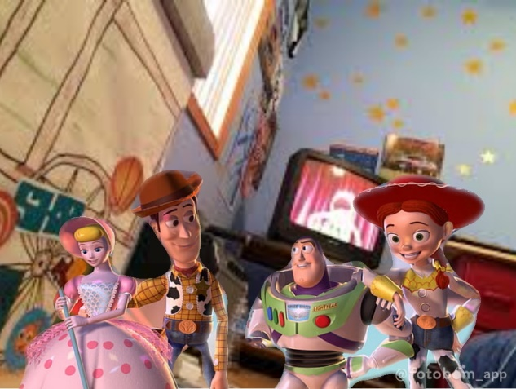
Meanwhile, in Andy’s room, the toys were nevous. They were waiting patiently for Sarge to report on the walkie talkie. Then, Hamm announced, “hey, heads up everybody. It’s showtime.” Rex was excited for Andy’s new toy. He said, excitedly, “maybe Andy will get another dinosaur. Like a leaf eater. That way I could play the, uh, dominant predator.” Jessie called out, “quiet, everyone! Quiet!” Sarge on the walkie talkie announced, “Andy’s second present is Trixie. Repeat, another dinosaur, Trixie!” “Way to go, Idaho!” Hamm smiled. “Horray!” Rex cheered, happily. Woody was about to come up to Buzz and Jessie, but Bo used her stick to pull Woody’s neck closer to Bo. “Oh, Bo. There’s got to be a less painful way to get my attention,” Woody gasped. “Merry Christmas, sheriff,” Bo smiled. Woody looked up and saw her sheep holding the mistletoe. He asked, “say, isn’t that mistletoe?” Bo kissed Woody. On the bed, Jessie was listening to Sarge announcing on the walkie talkie, but Buzz came up and said with a compliment, “uh, mam, I, uh… I wanted to say you’re a bright young woman with a beautiful, yarnful, of hair.” “Well, aren’t you the sweetest space toy since I met you since kindergarden,” Jessie smiled. Then, Woody and Bo came on the bed next to Buzz and Jessie. Woody asked, “Buzz, Buzz Lightyear, you are not worried, are you?” “Me? No. No, no, no, no. Are you?” Buzz asked. “Andy’s opening his large box… It’s-it’s-it’s…” Sarge announced on the walkie talkie. Woody smiled, “now, Buzz, what could Andy possibly get that is worse than going to Walt Disney World?” Andy shouted on the walkie talkie, “oh, what is it? What is it? Wow, an RC!” “Uh-oh!” Woody gasped. “Uh, Woody?” Buzz asked. “Just kidding!” Woody chuckled.

